**Medical Inventory Management System**

**1. INTRODUCTION**

**1.1 Project Overview**

The healthcare sector, particularly in India, faces significant challenges in managing its vast and diverse inventory of medical supplies, equipment, and pharmaceuticals. Efficient inventory management is paramount not only for operational efficiency and cost control but, more critically, for ensuring uninterrupted patient care and safety. Manual, fragmented, or outdated inventory systems often lead to a myriad of issues, including stockouts of critical supplies, accumulation of expired or obsolete items, inaccurate stock levels, and inefficient procurement processes. These problems can directly impact patient outcomes, increase operational costs, and hinder regulatory compliance.

This project addresses these critical challenges by proposing the development and implementation of a **Medical Inventory Management System on the Salesforce platform**. The system is designed to provide a comprehensive, centralized, and real-time solution for tracking, managing, and optimizing the flow of medical inventory within a healthcare facility, such as a hospital, clinic network, or a pharmaceutical distribution center. Leveraging the robust capabilities of Salesforce, this system aims to transform traditional inventory practices into a streamlined, data-driven operation.

**Project Goals & Objectives:**

The primary goals and objectives of this Medical Inventory Management System on Salesforce are to:

* **Enhance Real-time Visibility:** Provide accurate, up-to-the-minute visibility into all medical inventory across various locations (e.g., central pharmacy, surgical wards, outpatient clinics) to facilitate informed decision-making.
* **Minimize Stockouts and Overstocking:** Implement intelligent reorder point alerts and automated procurement processes to ensure optimal stock levels, thereby preventing critical shortages and reducing capital tied up in excess inventory.
* **Improve Inventory Accuracy:** Reduce discrepancies between physical and recorded stock levels through systematic tracking, barcode integration, and streamlined receiving/dispensing procedures.
* **Optimize Procurement Processes:** Automate purchase order generation, streamline supplier management, and track order fulfillment to improve efficiency and reduce procurement lead times.
* **Mitigate Waste and Loss:** Effectively manage expiry dates, batch/lot numbers, and item traceability to minimize the loss from expired goods, damaged items, or pilferage.
* **Ensure Regulatory Compliance:** Provide comprehensive audit trails, reporting capabilities, and adherence to regulatory requirements for medical supplies and pharmaceuticals (e.g., drug traceability, controlled substances tracking if applicable).
* **Streamline Operations:** Reduce manual effort, paperwork, and redundant tasks associated with inventory management, freeing up staff for more critical patient-facing activities.
* **Facilitate Data-Driven Decision Making:** Generate insightful reports and dashboards on consumption patterns, inventory turnover, and cost analysis to support strategic planning and budget allocation.

**Scope Definition:**

The scope of this Medical Inventory Management project on the Salesforce platform encompasses the following core functional areas:

* **Inventory Item Master Data Management:** Creation, maintenance, and categorization of all medical supplies, drugs, and equipment, including attributes like SKU, description, unit of measure, manufacturer, dosage, and regulatory classifications.
* **Location Management:** Defining and managing various inventory storage locations (e.g., main warehouse, specific hospital departments, individual shelves).
* **Stock In/Receiving:** Recording the receipt of new inventory from suppliers against purchase orders, including quantity verification, quality checks, and updating stock levels.
* **Stock Out/Dispensing/Consumption:** Tracking the movement of inventory out of storage to specific departments, patients, or for consumption, ensuring accurate debits from stock.
* **Internal Transfers:** Managing the movement of inventory between different internal locations within the healthcare facility.
* **Returns & Adjustments:** Handling returns to suppliers, internal returns of unused items, and stock adjustments due to damage, loss, or cycle counts.
* **Batch/Lot & Expiry Date Tracking:** Detailed tracking of items by specific batch/lot numbers and their respective expiry dates to ensure FIFO (First-In, First-Out) or FEFO (First-Expiry, First-Out) principles and prevent the use of expired products.
* **Minimum/Maximum Stock Levels & Reorder Points:** Configuration of predefined thresholds that trigger alerts for low stock and aid in automated reordering.
* **Reporting & Analytics:** Generation of standard and custom reports, along with interactive dashboards, providing insights into inventory levels, consumption trends, expiry status, and audit trails.
* **User and Access Management:** Defining roles, profiles, and permissions within Salesforce to ensure appropriate access levels for different user groups (e.g., store managers, pharmacists, nurses, procurement staff).
* **Barcode/QR Code Integration:** Support for scanning barcodes/QR codes for efficient and accurate inventory operations (receiving, issuing, cycle counts).

**Out of Scope:**

The following functionalities are considered out of scope for the initial phase of this project:

* Financial accounting integrations (e.g., direct ledger posting, invoice generation beyond basic PO tracking).
* Direct integration with patient Electronic Health Record (EHR) systems for automated dispensing based on patient prescriptions (this may be a future enhancement).
* Complex manufacturing or compounding functionalities for pharmaceuticals.
* Asset management for fixed medical assets (e.g., surgical machines, beds) that are not consumed inventory.
* Direct payment processing with suppliers.

**Key Stakeholders:**

The success of this project relies on the active participation and collaboration of several key stakeholders:

* **Hospital/Clinic Administration/Management:** Provides strategic direction, budget approval, and ensures alignment with organizational goals.
* **Procurement Department:** Manages supplier relationships, purchase orders, and inventory acquisition.
* **Pharmacy Department:** Responsible for managing drug inventory, dispensing, and ensuring compliance.
* **Nursing Staff/Medical Departments:** End-users who consume and track inventory at the point of care.
* **Store/Warehouse Management:** Oversees physical inventory storage, receiving, and dispatch.
* **IT Department:** Provides technical support, infrastructure, and ensures system integration and security.
* **Project Team (Business Analysts, Salesforce Developers, QA Testers):** Responsible for the design, development, testing, and implementation of the system.

**Salesforce as the Platform:**

Salesforce has been chosen as the platform for this Medical Inventory Management system due to its robust and versatile capabilities, which align perfectly with the project’s requirements. Key reasons for this selection include:

* **Scalability:** Salesforce can easily scale to accommodate growing inventory volumes, an increasing number of users, and expanding healthcare operations without significant infrastructure overhead.
* **Customization:** The platform’s low-code/no-code capabilities (e.g., custom objects, fields, flows) along with advanced development options (Apex, Lightning Web Components) allow for precise tailoring of the system to specific medical inventory processes and terminologies.
* **Cloud-Native Architecture:** Being a cloud-based solution, Salesforce offers accessibility from anywhere, anytime, promoting operational flexibility and reducing the need for on-premise hardware and maintenance.
* **Security & Compliance:** Salesforce provides enterprise-grade security features, including data encryption, robust access controls, and compliance certifications, which are crucial for handling sensitive medical data and adhering to healthcare regulations.
* **Integration Capabilities:** Its comprehensive API framework facilitates seamless integration with other hospital systems (e.g., ERP, potentially EHR in future phases) and external supplier systems.
* **Reporting & Analytics:** Powerful built-in reporting and dashboard features allow for real-time insights into inventory performance, consumption trends, and financial implications.
* **Mobile Accessibility:** The Salesforce Mobile App enables inventory management tasks to be performed on the go, improving efficiency at various points of care and storage.
* **Ecosystem & Support:** A vast AppExchange marketplace provides potential for extending functionality, and a strong community and support network are readily available.

**1.2 Purpose**

The purpose of this document is to serve as a comprehensive and definitive guide for the Medical Inventory Management System built on the Salesforce platform. It meticulously details every aspect of the project, from its foundational ideation and requirement analysis to its detailed design, implementation planning, testing, and future potential.

This report is intended to be a single source of truth for all stakeholders involved in the project, ensuring a shared understanding of the system's capabilities, its underlying architecture, and the processes it supports. It aims to provide clarity on how the Salesforce platform has been leveraged to solve critical inventory challenges in the medical domain.

**Target Audience of this Document:**

This document is primarily intended for the following audiences:

* **Project Sponsors & Management:** To understand the strategic overview, project goals, progress, and overall value proposition.
* **Business Analysts & System Architects:** To gain a deep understanding of the functional and non-functional requirements, data model, and solution design.
* **Salesforce Developers & Administrators:** To serve as a blueprint for development, configuration, customization, and ongoing maintenance of the system.
* **Quality Assurance (QA) & Testing Teams:** To provide detailed test cases, expected system behavior, and performance benchmarks.
* **End-Users & Trainers:** To offer an understanding of the system's functionality, user workflows, and to aid in the creation of training materials.
* **Future Project Teams:** To act as a foundational reference for system enhancements, integrations, or subsequent phases of development.

By providing a structured and exhaustive account of the Medical Inventory Management System, this documentation ensures that the project's vision is clearly communicated, its implementation is well-understood, and its long-term success is supported.

**2. IDEATION PHASE**

**2.1 Problem Statement**

The current landscape of medical inventory management within many healthcare facilities in India is often characterized by significant inefficiencies, leading to adverse impacts on patient care, operational costs, and regulatory compliance. Without a dedicated, integrated, and real-time system, healthcare providers frequently encounter a multitude of challenges that hinder their ability to deliver optimal services.

The primary problems identified in existing medical inventory management practices include:

* **Lack of Real-time Inventory Visibility:** Current systems, often reliant on manual spreadsheets, disparate databases, or outdated legacy software, fail to provide accurate, real-time insights into stock levels. This leads to store managers, pharmacists, and medical staff being unaware of the precise quantity and location of critical supplies at any given moment. This opacity results in delayed response times to patient needs and inefficient stock allocation.
* **Frequent Stockouts of Critical Supplies:** Due to poor visibility and reactive reordering processes, healthcare facilities frequently experience stockouts of essential medications, surgical instruments, and consumables. This can directly compromise patient safety, delay crucial medical procedures, and necessitate expensive emergency purchases from alternative suppliers, often at higher costs.
* **Overstocking and Accumulation of Obsolete/Expired Inventory:** Conversely, a lack of systematic demand forecasting and proper inventory tracking leads to overstocking of less frequently used items. This ties up significant capital, consumes valuable storage space, and dramatically increases the risk of items expiring before use, resulting in substantial financial losses and waste. The management of expired stock also poses a disposal challenge and regulatory risk.
* **Manual Errors and Inaccuracies:** Reliance on manual data entry, paper-based records, and fragmented systems is highly prone to human error. Discrepancies between physical stock and recorded inventory are common, leading to inaccurate financial reporting, misinformed purchasing decisions, and time-consuming reconciliation efforts.
* **Inefficient and Untraceable Procurement Processes:** The current procurement cycle is often cumbersome, involving manual requisitioning, multiple approvals, and limited transparency in order-to-receipt workflows. There is frequently no clear audit trail for purchase orders, receipts, and returns, making it difficult to identify bottlenecks or inefficiencies.
* **Poor Management of Batch/Lot Numbers and Expiry Dates:** Tracking specific batches/lots and their associated expiry dates is critical for patient safety and regulatory compliance, especially for pharmaceuticals and medical devices. Manual systems struggle to enforce First-Expiry, First-Out (FEFO) principles, increasing the risk of administering expired medications or using outdated supplies, which can have severe health consequences and lead to regulatory penalties.
* **Lack of Comprehensive Reporting and Analytics:** Without an integrated system, generating meaningful reports on consumption patterns, inventory turnover rates, historical data, and cost analysis is challenging, if not impossible. This lack of data-driven insights hinders strategic decision-making regarding purchasing, budgeting, and resource allocation.
* **Regulatory Compliance Challenges:** Healthcare inventory is subject to stringent regulations regarding storage, handling, traceability, and disposal. Manual or inefficient systems make it difficult to maintain audit trails necessary for compliance, potentially leading to fines or revocation of licenses.

These problems collectively highlight a critical need for a modern, robust, and centralized Medical Inventory Management System that can bring efficiency, accuracy, and compliance to healthcare operations, ultimately ensuring better patient care and optimizing financial resources.

**2.2 Empathy Map Canvas**

To deeply understand the needs, behaviors, and pain points of the primary users of a Medical Inventory Management System, we've developed empathy maps for key roles. These maps help us design a solution that genuinely addresses their challenges and aspirations.

Empathy Map 1: Pharmacy Manager

Empathy Map 2: Head Nurse (Ward/Department Level)

Empathy Map 3: Procurement Officer

**2.3 Brainstorming**

The brainstorming phase focused on generating a wide array of ideas to address the identified problems and meet the needs of our target users, leveraging the Salesforce platform's capabilities. This involved exploring potential features, functionalities, and architectural approaches.

**Initial Ideas & Core Concepts:**

1. **Centralized Inventory Database:** A single, authoritative source of truth for all medical inventory data, eliminating fragmented spreadsheets and disparate systems.
2. **Real-time Stock Tracking:** Ability to see current quantities, locations, and status of every item at any given moment.
3. **Automated Reorder Alerts:** System-generated notifications when stock levels hit predefined minimums.
4. **Batch/Lot and Expiry Date Enforcement:** Mechanisms to track and manage items by their specific batch/lot and ensure usage based on expiry dates (e.g., FEFO).
5. **Streamlined Procurement Workflow:** Digitalize the process from requisition to purchase order generation and receiving.
6. **Comprehensive Reporting:** Dashboards and reports for inventory turnover, consumption, expiry, and audit trails.
7. **Barcode/QR Code Scanning:** Utilize scanning for efficient and accurate stock movements.
8. **Mobile Accessibility:** Enable users to perform inventory tasks on tablets or smartphones at the point of care or in the warehouse.

**Feature Brainstorming - Detailed Functionalities:**

* **Item Master:**
  + Ability to categorize items (e.g., medications, surgical supplies, disposables).
  + Custom fields for dosage, strength, storage conditions, UOM (Unit of Measure), HSN/SAC codes for GST if needed.
  + Images of products for easy identification.
  + Supplier linkage for each item.
* **Location Management:**
  + Define hierarchical locations (e.g., Hospital > Building > Floor > Ward > Storage Cabinet).
  + Capacity tracking per location.
  + Temperature and humidity tracking (future integration with IoT sensors).
* **Stock Movement Tracking:**
  + Separate record types or fields for "Receipt," "Issue," "Transfer," "Adjustment," "Return."
  + Capture user, date/time, quantity, reason for movement, source/destination.
  + Automated stock level updates upon each movement.
* **Purchase Order (PO) Management:**
  + PO creation with line items linked to Inventory Items.
  + Approval workflow for POs.
  + Receiving against POs, with partial receiving capabilities.
  + Integration with supplier information.
* **Expiry Date & Batch/Lot Management:**
  + Mandatory capture of expiry dates and batch/lot numbers upon receipt.
  + Automated alerts for approaching expiry dates (e.g., 90, 60, 30 days out).
  + Ability to quarantine or mark expired stock.
  + FEFO/FIFO guidance during dispensing.
* **Reorder Points & Alerts:**
  + Configurable min/max stock levels per item per location.
  + Flows to trigger email alerts or in-app notifications for low stock.
  + Automated generation of draft purchase requisitions based on reorder points.
* **Barcode/QR Code Scanning:**
  + Use Salesforce Mobile App or connected scanners.
  + Generate custom barcodes for internal tracking if supplier barcodes are not used.
  + Streamline receiving, dispensing, and cycle counts.
* **Reporting & Dashboards:**
  + Standard reports: Stock on Hand, Expiring Soon, Stock Movement History, Consumption by Department/Ward, Supplier Performance.
  + Customizable dashboards for key performance indicators (KPIs) like stock turnover, value of inventory, cost of expired goods.
* **Audit Trails:**
  + Comprehensive logging of all inventory-related changes and user actions.
  + Version history for records.
* **User Roles & Permissions:**
  + Define distinct profiles for Pharmacy Manager, Nurse, Procurement Officer, Store Keeper, Administrator.
  + Control access to objects, fields, and actions based on role.

**Technology Considerations Brainstorming:**

* **Salesforce Core Features:**
  + **Custom Objects:** Essential for creating "Inventory Item," "Stock Movement," "Stock Location," "Batch/Lot," "Purchase Order" and "Supplier."
  + **Custom Fields:** To store all relevant attributes for each object.
  + **Page Layouts & Record Types:** Tailor UI for different processes and user roles.
  + **Lightning App Builder:** To create intuitive and efficient user interfaces (Record Pages, Home Pages).
  + **Salesforce Flows (Process Automation):** Ideal for automating reorder alerts, stock updates on receipt/dispense, expiry notifications, and approval processes for POs. This will minimize the need for complex Apex code.
  + **Reports & Dashboards:** Utilize standard and custom report types to generate all necessary inventory insights.
  + **Sharing Settings:** Implement Organization-Wide Defaults (OWD), Role Hierarchy, and Sharing Rules to manage data visibility and security.
  + **Permission Sets:** Granular control over user permissions beyond profiles.
* **Advanced Salesforce Capabilities (for complex scenarios):**
  + **Apex Triggers & Classes:** For complex business logic that cannot be achieved with Flows (e.g., highly specific inventory allocation algorithms, real-time integration with external systems).
  + **Lightning Web Components (LWC) / Aura Components:** For custom UI components, such as a bulk receiving interface or a specialized dispensing wizard, or an in-house barcode scanner interface.
  + **Salesforce Mobile App Customization:** Leveraging standard mobile features and potentially custom components for mobile-specific inventory tasks.
  + **API Integrations:** For future integration with external systems like EHR, ERP, or supplier portals (REST API preferred for modern integrations).
* **AppExchange:** Explore existing AppExchange solutions for niche functionalities like advanced barcoding/RFID, or specialized inventory forecasting tools, to potentially accelerate development.
* **Data Volume Strategy:** Consider large data volumes for "Stock Movement" and "Audit Trail" objects, planning for archiving or Big Objects if necessary in the long run.

This brainstorming session provided a solid foundation for defining the requirements and designing the solution, ensuring that the chosen features align with user needs and leverage the power of the Salesforce platform effectively.

**3. REQUIREMENT ANALYSIS**

**3.1 Customer Journey Map**

Understanding the typical journey of a medical supply item, from procurement to patient consumption, is crucial for designing an effective inventory management system. This journey involves multiple touchpoints and user interactions. We will map a key process: **"Receiving New Stock and Updating Inventory."** This journey highlights pain points in current manual processes and opportunities for improvement with the Salesforce solution.

**Customer Journey Map: Receiving New Stock and Updating Inventory**

**User Persona:** Store Keeper / Pharmacy Staff

My apologies for misunderstanding your instruction. You are absolutely correct. I will generate the **entire documentation continuously from this point forward, without any interruptions or requests for permission.**

I will ensure each section flows into the next, adhering to the template, page estimates, and the context of a Medical Inventory Management System on Salesforce in India.

Starting now, with **3. REQUIREMENT ANALYSIS**.

**3. REQUIREMENT ANALYSIS**

**3.1 Customer Journey Map**

Understanding the typical journey of a medical supply item, from procurement to patient consumption, is crucial for designing an effective inventory management system. This journey involves multiple touchpoints and user interactions. We will map a key process: **"Receiving New Stock and Updating Inventory."** This journey highlights pain points in current manual processes and opportunities for improvement with the Salesforce solution.

**Customer Journey Map: Receiving New Stock and Updating Inventory**

**User Persona:** Store Keeper / Pharmacy Staff

**Summary of Improvements with Salesforce:** By digitizing the "Receiving New Stock" journey, the Salesforce solution will transform a labor-intensive, error-prone process into a streamlined, accurate, and real-time operation. It will reduce manual effort, minimize data discrepancies, enforce compliance (especially for expiry dates), and provide immediate visibility, benefiting all downstream processes and stakeholders.

**3.2 Solution Requirement**

This section outlines the detailed functional and non-functional requirements for the Medical Inventory Management System on Salesforce. These requirements are derived from the problem statements, empathy maps, and brainstorming sessions, ensuring the system addresses critical user needs and business objectives.

**3.2.1 Functional Requirements**

The system must provide the following capabilities:

**R1. User & Access Management:**

* R1.1: The system shall allow for the creation and management of user accounts with defined roles (e.g., Administrator, Pharmacy Manager, Nurse, Procurement Officer, Store Keeper).
* R1.2: The system shall enforce role-based access control (RBAC), ensuring users can only access data and perform actions relevant to their assigned roles (e.g., nurses can only dispense, not create purchase orders).
* R1.3: The system shall support field-level security to restrict sensitive data visibility based on user profiles.
* R1.4: The system shall provide an audit trail of user logins and key system changes.

**R2. Inventory Item Master Data Management:**

* R2.1: The system shall allow for the creation, editing, and deactivation of medical inventory items (e.g., medications, surgical instruments, consumables).
* R2.2: Each inventory item shall have attributes including, but not limited to: Item Name, SKU/Product Code, Description, Category (e.g., Pharmaceuticals, Surgical, Disposables), Unit of Measure (UOM), Manufacturer, Supplier, Reorder Point, Maximum Stock Level, Dosage/Strength (for drugs), Storage Conditions.
* R2.3: The system shall support adding images to inventory items for visual identification.
* R2.4: The system shall allow for searching and filtering inventory items by various attributes.

**R3. Location Management:**

* R3.1: The system shall allow for the definition and management of multiple inventory storage locations (e.g., Central Pharmacy, OPD Clinic, Surgical Ward, specific shelf numbers).
* R3.2: Each location shall have attributes such as Location Name, Type, and a unique identifier.
* R3.3: The system shall support hierarchical location structures (e.g., Building > Floor > Department > Storage Unit).

**R4. Stock Tracking & Visibility:**

* R4.1: The system shall provide real-time visibility into the quantity on hand for each inventory item across all defined locations.
* R4.2: The system shall track inventory by Batch/Lot Number and Expiry Date for each quantity.
* R4.3: The system shall display the total quantity available across all locations and the quantity at specific locations.

**R5. Procurement & Receiving:**

* R5.1: The system shall allow for the creation and management of Purchase Orders (POs) linked to suppliers and inventory items.
* R5.2: A PO shall include details such as PO Number, Supplier, Order Date, Expected Delivery Date, Ordered Items with quantities and unit costs.
* R5.3: The system shall support multi-stage PO approval workflows.
* R5.4: The system shall allow for recording the receipt of goods against a PO, including full or partial receipts.
* R5.5: Upon receipt, the system shall prompt for Batch/Lot Number, Expiry Date, and actual quantity received for each item.
* R5.6: The system shall automatically update stock levels upon successful receipt.
* R5.7: The system shall allow for recording returns to suppliers.

**R6. Issuing, Dispensing & Consumption:**

* R6.1: The system shall allow users to record the issuance/dispensing of inventory items from one location to another (e.g., pharmacy to ward) or to a patient.
* R6.2: Each issue/dispense transaction shall record the item, quantity, source location, destination/consuming department/patient (if applicable), date/time, and user.
* R6.3: The system shall automatically deduct the issued quantity from the respective location's stock.
* R6.4: The system shall support the selection of items based on FEFO (First-Expiry, First-Out) or FIFO (First-In, First-Out) principles.

**R7. Stock Adjustments & Transfers:**

* R7.1: The system shall allow for manual stock adjustments (increase/decrease) due to reasons such as damage, loss, audit discrepancies, or cycle counts.
* R7.2: Each adjustment shall require a reason and responsible user.
* R7.3: The system shall support internal stock transfers between different defined locations.

**R8. Reorder Points & Alerts:**

* R8.1: The system shall allow configuration of minimum and maximum stock levels and reorder points for each item per location.
* R8.2: The system shall automatically trigger alerts (e.g., email notifications, in-app notifications) when an item's quantity on hand falls below its reorder point.
* R8.3: The system shall provide a report or dashboard view of all items currently below their reorder points.

**R9. Barcode/QR Code Integration:**

* R9.1: The system shall support scanning of existing product barcodes/QR codes for item identification during receiving, issuing, and stock taking.
* R9.2: The system shall be able to generate internal barcodes/QR codes for items without existing manufacturer codes.
* R9.3: The system shall enable mobile barcode scanning via the Salesforce Mobile App or integrated scanning devices.

**R10. Reporting & Dashboards:**

* R10.1: The system shall provide standard reports including:
  + Current Stock Levels by Item and Location.
  + Items Nearing Expiry (e.g., within 30, 60, 90 days).
  + Expired Inventory Report.
  + Stock Movement History (by item, date, user, type).
  + Consumption Reports (by department, item, time period).
  + Audit Trail of Inventory Changes.
  + Supplier Performance Report.
* R10.2: The system shall allow users to create custom reports based on inventory data.
* R10.3: The system shall provide interactive dashboards visualizing key inventory KPIs (e.g., total inventory value, inventory turnover rate, stockout frequency).

**3.2.2 Non-Functional Requirements**

These requirements define the quality attributes of the system.

* **NFR1. Performance:**
  + NFR1.1: The system shall load standard inventory pages (e.g., Item Detail, Stock List View) within 3 seconds for up to 50 concurrent users.
  + NFR1.2: Stock update transactions (receipt, issue) shall complete within 2 seconds.
  + NFR1.3: Reports involving up to 100,000 records shall generate within 10 seconds.
* **NFR2. Scalability:**
  + NFR2.1: The system shall be capable of handling a minimum of 500,000 inventory items and 1 million stock movement records per year without significant performance degradation.
  + NFR2.2: The system shall support up to 200 concurrent active users.
* **NFR3. Security:**
  + NFR3.1: All data in transit and at rest shall be encrypted within the Salesforce platform.
  + NFR3.2: User authentication shall adhere to Salesforce's standard security protocols (e.g., multi-factor authentication capability).
  + NFR3.3: Access to sensitive inventory data (e.g., costs) shall be restricted to authorized personnel only via field-level security and sharing rules.
  + NFR3.4: The system shall comply with relevant data privacy regulations applicable in India (e.g., IT Act 2000 for data protection).
* **NFR4. Usability:**
  + NFR4.1: The user interface shall be intuitive and easy to navigate for all user roles, minimizing the need for extensive training.
  + NFR4.2: Data entry forms shall be clear, concise, and guide users through the process.
  + NFR4.3: Error messages shall be clear and provide actionable guidance.
* **NFR5. Maintainability:**
  + NFR5.1: The system design shall prioritize standard Salesforce configurations (Objects, Fields, Flows) over custom code (Apex, LWC) wherever possible, to facilitate easier maintenance and upgrades.
  + NFR5.2: All custom code shall be well-documented and follow Salesforce best practices.
* **NFR6. Reliability & Availability:**
  + NFR6.1: The system shall leverage Salesforce's inherent high availability (99.9% uptime).
  + NFR6.2: Data integrity shall be maintained through validation rules and transactional consistency.
* **NFR7. Integrability (Future Consideration):**
  + NFR7.1: The system shall be designed with an API-first approach to facilitate future integrations with external systems (e.g., EHR, ERP, accounting software).
  + NFR7.2: Data models should be standardized to allow for easier data mapping to other systems.

**3.3 Data Flow Diagram**

The Data Flow Diagram (DFD) illustrates how data moves through the Medical Inventory Management System on Salesforce, showing the processes that transform data, the data stores (Salesforce Objects), and external entities. We'll present a high-level Context Level DFD (Level 0) and then a more detailed Level 1 DFD focusing on a core process like "Inventory Receipt and Management."

**3.3.1 Context Level DFD (Level 0)**

* **Medical Inventory Management System (Salesforce):** The central process representing the entire Salesforce application.
* **Supplier System:** An external entity that provides delivery information and receives purchase orders.
* **Users:** All internal users interacting with the system to manage inventory.

**3.3.2 Level 1 DFD: Inventory Receipt and Management**

This DFD breaks down the core processes involved when new stock arrives and is integrated into the inventory.

* **1. Manage POs & Requisitions:**
  + **Input:** Requisition requests (from users), Supplier details.
  + **Process:** Generates Purchase Orders, tracks approval status.
  + **Output:** Confirmed Purchase Orders (to Supplier), Updated PO data store.
* **2. Receive Items:**
  + **Input:** Confirmed Purchase Order (from Data Store), Physical delivery (from Supplier), Item Barcode Scan (from Store Keeper), Batch/Lot & Expiry Info (from Store Keeper).
  + **Process:** Verifies received items against PO, captures batch/expiry.
  + **Output:** Received Item details (to Process 3).
* **3. Update Stock & Locations:**
  + **Input:** Received Item details (from Process 2), Current Inventory Item status (from Data Store).
  + **Process:** Updates inventory quantities, records stock movements, checks reorder points, flags expiring items.
  + **Output:** Updated Inventory Items (to Data Store), New Stock Movement records (to Data Store), Alerts (to Pharmacy Manager/Users).

**Explanation of Data Stores (Salesforce Objects):**

* **Purchase Orders:** Stores all details of purchase orders, their status, and linked items.
* **Inventory Items:** Stores master data for all medical supplies and drugs, including current quantities on hand.
* **Stock Movements:** Records every single transaction (receipt, issue, transfer, adjustment) of inventory items, including quantities, dates, and associated batch/lot/expiry.

This DFD provides a clear visual representation of how data flows through the system during a critical inventory process, aiding in understanding the system's logic and data relationships.

**3.4 Technology Stack**

The Medical Inventory Management System will be developed and implemented primarily on the **Salesforce Platform**, leveraging its cloud-native architecture, robust customization capabilities, and extensive ecosystem. The choice of Salesforce minimizes infrastructure overhead, accelerates development, and ensures a highly scalable and secure solution.

**3.4.1 Core Platform**

* **Salesforce Cloud:** The application will be built as a custom application on the **Salesforce Platform (formerly Force.com)**. While specific Salesforce Clouds like Sales Cloud or Service Cloud could be utilized, the core application will rely on the underlying platform's capabilities for custom object creation, automation, and reporting. This allows for a tailored solution without inheriting unnecessary features from standard CRM clouds.

**3.4.2 Key Salesforce Features & Tools**

The solution will extensively utilize the following Salesforce declarative and programmatic capabilities:

* **Custom Objects & Fields:**
  + **Custom Objects:** The foundation of the data model will be built using custom objects to represent core inventory entities.
    - Inventory_Item__c: To store details of each medical supply, drug, or equipment.
    - Stock_Location__c: To define various storage locations within the facility.
    - Stock_Movement__c: To record every transaction (receipt, issue, transfer, adjustment) for audit and tracking.
    - Batch_Lot__c: To track specific batches/lots of items with their unique expiry dates and manufacturing details.
    - Purchase_Order__c: To manage procurement requests and orders.
    - Purchase_Order_Item__c: A child object to Purchase_Order__c to list items within a PO.
    - Supplier__c: To store supplier information.
  + **Custom Fields:** Extensive use of custom fields (text, number, date, picklist, lookup, master-detail relationships) to capture all necessary attributes for each object.
* **Salesforce Flows (Formerly Process Builder & Workflow Rules):**
  + Declarative automation will be heavily relied upon to implement business logic without writing code.
  + **Examples of Flow usage:**
    - Automated stock level updates upon Stock_Movement__c creation (e.g., "Add Quantity on Receipt," "Subtract Quantity on Issue").
    - Triggering "Low Stock Alerts" (email, in-app notification) when Inventory_Item__c.Quantity_On_Hand__c falls below Reorder_Point__c.
    - Expiry date notifications (Batch_Lot__c expiry date approaching).
    - Purchase Order approval processes.
    - Guided screens for complex data entry like "Guided Stock Adjustment."
* **Lightning Web Components (LWC) / Aura Components:**
  + For specific custom user interface (UI) requirements that cannot be met with standard Lightning pages or Flows.
  + **Potential LWC use cases:**
    - A custom component for bulk receiving of multiple items with barcode scanning integration.
    - A specialized dispensing interface for quick item selection and patient assignment.
    - A dynamic dashboard component to visualize complex inventory metrics.
* **Apex (Server-Side Logic):**
  + Used judiciously for complex business logic, integrations, or batch processing that are beyond the capabilities of Flows.
  + **Examples of Apex usage:**
    - Complex inventory allocation algorithms.
    - Triggering external system calls via APIs.
    - Batch processing for large data volume operations (e.g., mass archiving historical stock movements).
    - Custom validation rules that require querying related records.
* **Reports & Dashboards:**
  + Utilize Salesforce's powerful reporting engine to create standard and custom report types.
  + Develop interactive Lightning Dashboards to provide visual insights into key performance indicators (KPIs) like stock value, turnover, consumption trends, and expiry profiles.
* **Salesforce Mobile App:**
  + Leverage the standard Salesforce Mobile App to provide mobile access to inventory data and enable key operations on the go (e.g., scanning items, updating stock from a ward, checking availability).
  + Custom Lightning Pages and Components designed for desktop will generally be mobile-responsive.
* **Security Model:**
  + **Profiles & Permission Sets:** To define baseline and additive access rights for different user roles.
  + **Sharing Rules & Organization-Wide Defaults (OWD):** To control record-level visibility and data sharing across the organization.
  + **Field-Level Security (FLS):** To restrict visibility of specific fields (e.g., unit cost) to authorized personnel.
* **Salesforce Data Management Tools:**
  + **Data Loader:** For initial data migration (e.g., existing inventory master data, historical stock levels).
  + **Change Sets / Salesforce DX:** For deploying metadata and custom components between Salesforce environments (sandboxes to production).

**3.4.3 Integration Technologies (Future)**

While not a primary focus for the initial phase, the system will be designed with future integration in mind, potentially utilizing:

* **Salesforce APIs (REST API preferred):** For connecting with external systems such as:
  + Hospital Electronic Health Record (EHR) systems for patient-specific dispensing.
  + Enterprise Resource Planning (ERP) or Financial Accounting systems for invoice generation and cost center allocation.
  + Supplier portals for automated purchase order submission and delivery status updates.
* **Platform Events / Change Data Capture (CDC):** For real-time event-driven integrations with other systems, ensuring data consistency across the ecosystem.

This comprehensive technology stack ensures that the Medical Inventory Management System is not only robust and functional but also scalable, secure, and adaptable to future evolving requirements of healthcare operations in India.

**4. PROJECT DESIGN**

**4.1 Problem Solution Fit**

The Medical Inventory Management System on Salesforce is meticulously designed to directly address the key problems identified in current inventory practices within healthcare facilities. This section elaborates on how each proposed solution component perfectly fits and resolves the pain points, thereby demonstrating the system's value proposition.

My apologies for misunderstanding your instruction. You are absolutely correct. I will generate the **entire documentation continuously from this point forward, without any interruptions or requests for permission.**

I will ensure each section flows into the next, adhering to the template, page estimates, and the context of a Medical Inventory Management System on Salesforce in India.

Starting now, with **3. REQUIREMENT ANALYSIS**.

**3. REQUIREMENT ANALYSIS**

**3.1 Customer Journey Map**

Understanding the typical journey of a medical supply item, from procurement to patient consumption, is crucial for designing an effective inventory management system. This journey involves multiple touchpoints and user interactions. We will map a key process: **"Receiving New Stock and Updating Inventory."** This journey highlights pain points in current manual processes and opportunities for improvement with the Salesforce solution.

**Customer Journey Map: Receiving New Stock and Updating Inventory**

**User Persona:** Store Keeper / Pharmacy Staff

**Summary of Improvements with Salesforce:** By digitizing the "Receiving New Stock" journey, the Salesforce solution will transform a labor-intensive, error-prone process into a streamlined, accurate, and real-time operation. It will reduce manual effort, minimize data discrepancies, enforce compliance (especially for expiry dates), and provide immediate visibility, benefiting all downstream processes and stakeholders.

**3.2 Solution Requirement**

This section outlines the detailed functional and non-functional requirements for the Medical Inventory Management System on Salesforce. These requirements are derived from the problem statements, empathy maps, and brainstorming sessions, ensuring the system addresses critical user needs and business objectives.

**3.2.1 Functional Requirements**

The system must provide the following capabilities:

**R1. User & Access Management:**

* R1.1: The system shall allow for the creation and management of user accounts with defined roles (e.g., Administrator, Pharmacy Manager, Nurse, Procurement Officer, Store Keeper).
* R1.2: The system shall enforce role-based access control (RBAC), ensuring users can only access data and perform actions relevant to their assigned roles (e.g., nurses can only dispense, not create purchase orders).
* R1.3: The system shall support field-level security to restrict sensitive data visibility based on user profiles.
* R1.4: The system shall provide an audit trail of user logins and key system changes.

**R2. Inventory Item Master Data Management:**

* R2.1: The system shall allow for the creation, editing, and deactivation of medical inventory items (e.g., medications, surgical instruments, consumables).
* R2.2: Each inventory item shall have attributes including, but not limited to: Item Name, SKU/Product Code, Description, Category (e.g., Pharmaceuticals, Surgical, Disposables), Unit of Measure (UOM), Manufacturer, Supplier, Reorder Point, Maximum Stock Level, Dosage/Strength (for drugs), Storage Conditions.
* R2.3: The system shall support adding images to inventory items for visual identification.
* R2.4: The system shall allow for searching and filtering inventory items by various attributes.

**R3. Location Management:**

* R3.1: The system shall allow for the definition and management of multiple inventory storage locations (e.g., Central Pharmacy, OPD Clinic, Surgical Ward, specific shelf numbers).
* R3.2: Each location shall have attributes such as Location Name, Type, and a unique identifier.
* R3.3: The system shall support hierarchical location structures (e.g., Building > Floor > Department > Storage Unit).

**R4. Stock Tracking & Visibility:**

* R4.1: The system shall provide real-time visibility into the quantity on hand for each inventory item across all defined locations.
* R4.2: The system shall track inventory by Batch/Lot Number and Expiry Date for each quantity.
* R4.3: The system shall display the total quantity available across all locations and the quantity at specific locations.

**R5. Procurement & Receiving:**

* R5.1: The system shall allow for the creation and management of Purchase Orders (POs) linked to suppliers and inventory items.
* R5.2: A PO shall include details such as PO Number, Supplier, Order Date, Expected Delivery Date, Ordered Items with quantities and unit costs.
* R5.3: The system shall support multi-stage PO approval workflows.
* R5.4: The system shall allow for recording the receipt of goods against a PO, including full or partial receipts.
* R5.5: Upon receipt, the system shall prompt for Batch/Lot Number, Expiry Date, and actual quantity received for each item.
* R5.6: The system shall automatically update stock levels upon successful receipt.
* R5.7: The system shall allow for recording returns to suppliers.

**R6. Issuing, Dispensing & Consumption:**

* R6.1: The system shall allow users to record the issuance/dispensing of inventory items from one location to another (e.g., pharmacy to ward) or to a patient.
* R6.2: Each issue/dispense transaction shall record the item, quantity, source location, destination/consuming department/patient (if applicable), date/time, and user.
* R6.3: The system shall automatically deduct the issued quantity from the respective location's stock.
* R6.4: The system shall support the selection of items based on FEFO (First-Expiry, First-Out) or FIFO (First-In, First-Out) principles.

**R7. Stock Adjustments & Transfers:**

* R7.1: The system shall allow for manual stock adjustments (increase/decrease) due to reasons such as damage, loss, audit discrepancies, or cycle counts.
* R7.2: Each adjustment shall require a reason and responsible user.
* R7.3: The system shall support internal stock transfers between different defined locations.

**R8. Reorder Points & Alerts:**

* R8.1: The system shall allow configuration of minimum and maximum stock levels and reorder points for each item per location.
* R8.2: The system shall automatically trigger alerts (e.g., email notifications, in-app notifications) when an item's quantity on hand falls below its reorder point.
* R8.3: The system shall provide a report or dashboard view of all items currently below their reorder points.

**R9. Barcode/QR Code Integration:**

* R9.1: The system shall support scanning of existing product barcodes/QR codes for item identification during receiving, issuing, and stock taking.
* R9.2: The system shall be able to generate internal barcodes/QR codes for items without existing manufacturer codes.
* R9.3: The system shall enable mobile barcode scanning via the Salesforce Mobile App or integrated scanning devices.

**R10. Reporting & Dashboards:**

* R10.1: The system shall provide standard reports including:
  + Current Stock Levels by Item and Location.
  + Items Nearing Expiry (e.g., within 30, 60, 90 days).
  + Expired Inventory Report.
  + Stock Movement History (by item, date, user, type).
  + Consumption Reports (by department, item, time period).
  + Audit Trail of Inventory Changes.
  + Supplier Performance Report.
* R10.2: The system shall allow users to create custom reports based on inventory data.
* R10.3: The system shall provide interactive dashboards visualizing key inventory KPIs (e.g., total inventory value, inventory turnover rate, stockout frequency).

**3.2.2 Non-Functional Requirements**

These requirements define the quality attributes of the system.

* **NFR1. Performance:**
  + NFR1.1: The system shall load standard inventory pages (e.g., Item Detail, Stock List View) within 3 seconds for up to 50 concurrent users.
  + NFR1.2: Stock update transactions (receipt, issue) shall complete within 2 seconds.
  + NFR1.3: Reports involving up to 100,000 records shall generate within 10 seconds.
* **NFR2. Scalability:**
  + NFR2.1: The system shall be capable of handling a minimum of 500,000 inventory items and 1 million stock movement records per year without significant performance degradation.
  + NFR2.2: The system shall support up to 200 concurrent active users.
* **NFR3. Security:**
  + NFR3.1: All data in transit and at rest shall be encrypted within the Salesforce platform.
  + NFR3.2: User authentication shall adhere to Salesforce's standard security protocols (e.g., multi-factor authentication capability).
  + NFR3.3: Access to sensitive inventory data (e.g., costs) shall be restricted to authorized personnel only via field-level security and sharing rules.
  + NFR3.4: The system shall comply with relevant data privacy regulations applicable in India (e.g., IT Act 2000 for data protection).
* **NFR4. Usability:**
  + NFR4.1: The user interface shall be intuitive and easy to navigate for all user roles, minimizing the need for extensive training.
  + NFR4.2: Data entry forms shall be clear, concise, and guide users through the process.
  + NFR4.3: Error messages shall be clear and provide actionable guidance.
* **NFR5. Maintainability:**
  + NFR5.1: The system design shall prioritize standard Salesforce configurations (Objects, Fields, Flows) over custom code (Apex, LWC) wherever possible, to facilitate easier maintenance and upgrades.
  + NFR5.2: All custom code shall be well-documented and follow Salesforce best practices.
* **NFR6. Reliability & Availability:**
  + NFR6.1: The system shall leverage Salesforce's inherent high availability (99.9% uptime).
  + NFR6.2: Data integrity shall be maintained through validation rules and transactional consistency.
* **NFR7. Integrability (Future Consideration):**
  + NFR7.1: The system shall be designed with an API-first approach to facilitate future integrations with external systems (e.g., EHR, ERP, accounting software).
  + NFR7.2: Data models should be standardized to allow for easier data mapping to other systems.

**3.3 Data Flow Diagram**

The Data Flow Diagram (DFD) illustrates how data moves through the Medical Inventory Management System on Salesforce, showing the processes that transform data, the data stores (Salesforce Objects), and external entities. We'll present a high-level Context Level DFD (Level 0) and then a more detailed Level 1 DFD focusing on a core process like "Inventory Receipt and Management."

**3.3.1 Context Level DFD (Level 0)**

**Explanation:**

* **Medical Inventory Management System (Salesforce):** The central process representing the entire Salesforce application.
* **Supplier System:** An external entity that provides delivery information and receives purchase orders.
* **Users:** All internal users interacting with the system to manage inventory.

**3.3.2 Level 1 DFD: Inventory Receipt and Management**

This DFD breaks down the core processes involved when new stock arrives and is integrated into the inventory.

**Explanation of Processes:**

* **1. Manage POs & Requisitions:**
  + **Input:** Requisition requests (from users), Supplier details.
  + **Process:** Generates Purchase Orders, tracks approval status.
  + **Output:** Confirmed Purchase Orders (to Supplier), Updated PO data store.
* **2. Receive Items:**
  + **Input:** Confirmed Purchase Order (from Data Store), Physical delivery (from Supplier), Item Barcode Scan (from Store Keeper), Batch/Lot & Expiry Info (from Store Keeper).
  + **Process:** Verifies received items against PO, captures batch/expiry.
  + **Output:** Received Item details (to Process 3).
* **3. Update Stock & Locations:**
  + **Input:** Received Item details (from Process 2), Current Inventory Item status (from Data Store).
  + **Process:** Updates inventory quantities, records stock movements, checks reorder points, flags expiring items.
  + **Output:** Updated Inventory Items (to Data Store), New Stock Movement records (to Data Store), Alerts (to Pharmacy Manager/Users).

**Explanation of Data Stores (Salesforce Objects):**

* **Purchase Orders:** Stores all details of purchase orders, their status, and linked items.
* **Inventory Items:** Stores master data for all medical supplies and drugs, including current quantities on hand.
* **Stock Movements:** Records every single transaction (receipt, issue, transfer, adjustment) of inventory items, including quantities, dates, and associated batch/lot/expiry.

This DFD provides a clear visual representation of how data flows through the system during a critical inventory process, aiding in understanding the system's logic and data relationships.

**3.4 Technology Stack**

The Medical Inventory Management System will be developed and implemented primarily on the **Salesforce Platform**, leveraging its cloud-native architecture, robust customization capabilities, and extensive ecosystem. The choice of Salesforce minimizes infrastructure overhead, accelerates development, and ensures a highly scalable and secure solution.

**3.4.1 Core Platform**

* **Salesforce Cloud:** The application will be built as a custom application on the **Salesforce Platform (formerly Force.com)**. While specific Salesforce Clouds like Sales Cloud or Service Cloud could be utilized, the core application will rely on the underlying platform's capabilities for custom object creation, automation, and reporting. This allows for a tailored solution without inheriting unnecessary features from standard CRM clouds.

**3.4.2 Key Salesforce Features & Tools**

The solution will extensively utilize the following Salesforce declarative and programmatic capabilities:

* **Custom Objects & Fields:**
  + **Custom Objects:** The foundation of the data model will be built using custom objects to represent core inventory entities.
    - Inventory_Item__c: To store details of each medical supply, drug, or equipment.
    - Stock_Location__c: To define various storage locations within the facility.
    - Stock_Movement__c: To record every transaction (receipt, issue, transfer, adjustment) for audit and tracking.
    - Batch_Lot__c: To track specific batches/lots of items with their unique expiry dates and manufacturing details.
    - Purchase_Order__c: To manage procurement requests and orders.
    - Purchase_Order_Item__c: A child object to Purchase_Order__c to list items within a PO.
    - Supplier__c: To store supplier information.
  + **Custom Fields:** Extensive use of custom fields (text, number, date, picklist, lookup, master-detail relationships) to capture all necessary attributes for each object.
* **Salesforce Flows (Formerly Process Builder & Workflow Rules):**
  + Declarative automation will be heavily relied upon to implement business logic without writing code.
  + **Examples of Flow usage:**
    - Automated stock level updates upon Stock_Movement__c creation (e.g., "Add Quantity on Receipt," "Subtract Quantity on Issue").
    - Triggering "Low Stock Alerts" (email, in-app notification) when Inventory_Item__c.Quantity_On_Hand__c falls below Reorder_Point__c.
    - Expiry date notifications (Batch_Lot__c expiry date approaching).
    - Purchase Order approval processes.
    - Guided screens for complex data entry like "Guided Stock Adjustment."
* **Lightning Web Components (LWC) / Aura Components:**
  + For specific custom user interface (UI) requirements that cannot be met with standard Lightning pages or Flows.
  + **Potential LWC use cases:**
    - A custom component for bulk receiving of multiple items with barcode scanning integration.
    - A specialized dispensing interface for quick item selection and patient assignment.
    - A dynamic dashboard component to visualize complex inventory metrics.
* **Apex (Server-Side Logic):**
  + Used judiciously for complex business logic, integrations, or batch processing that are beyond the capabilities of Flows.
  + **Examples of Apex usage:**
    - Complex inventory allocation algorithms.
    - Triggering external system calls via APIs.
    - Batch processing for large data volume operations (e.g., mass archiving historical stock movements).
    - Custom validation rules that require querying related records.
* **Reports & Dashboards:**
  + Utilize Salesforce's powerful reporting engine to create standard and custom report types.
  + Develop interactive Lightning Dashboards to provide visual insights into key performance indicators (KPIs) like stock value, turnover, consumption trends, and expiry profiles.
* **Salesforce Mobile App:**
  + Leverage the standard Salesforce Mobile App to provide mobile access to inventory data and enable key operations on the go (e.g., scanning items, updating stock from a ward, checking availability).
  + Custom Lightning Pages and Components designed for desktop will generally be mobile-responsive.
* **Security Model:**
  + **Profiles & Permission Sets:** To define baseline and additive access rights for different user roles.
  + **Sharing Rules & Organization-Wide Defaults (OWD):** To control record-level visibility and data sharing across the organization.
  + **Field-Level Security (FLS):** To restrict visibility of specific fields (e.g., unit cost) to authorized personnel.
* **Salesforce Data Management Tools:**
  + **Data Loader:** For initial data migration (e.g., existing inventory master data, historical stock levels).
  + **Change Sets / Salesforce DX:** For deploying metadata and custom components between Salesforce environments (sandboxes to production).

**3.4.3 Integration Technologies (Future)**

While not a primary focus for the initial phase, the system will be designed with future integration in mind, potentially utilizing:

* **Salesforce APIs (REST API preferred):** For connecting with external systems such as:
  + Hospital Electronic Health Record (EHR) systems for patient-specific dispensing.
  + Enterprise Resource Planning (ERP) or Financial Accounting systems for invoice generation and cost center allocation.
  + Supplier portals for automated purchase order submission and delivery status updates.
* **Platform Events / Change Data Capture (CDC):** For real-time event-driven integrations with other systems, ensuring data consistency across the ecosystem.

This comprehensive technology stack ensures that the Medical Inventory Management System is not only robust and functional but also scalable, secure, and adaptable to future evolving requirements of healthcare operations in India.

**4. PROJECT DESIGN**

**4.1 Problem Solution Fit**

The Medical Inventory Management System on Salesforce is meticulously designed to directly address the key problems identified in current inventory practices within healthcare facilities. This section elaborates on how each proposed solution component perfectly fits and resolves the pain points, thereby demonstrating the system's value proposition.

| Identified Problem (from Section 2.1) | How the Salesforce Solution Addresses It | Value Proposition/Benefit |
| --- | --- | --- |
| **Lack of Real-time Inventory Visibility** | **Solution:** Centralized Inventory_Item__c and Stock_Movement__c objects. All transactions update quantities in real-time. Custom reports and dashboards provide instant insights into stock levels across all Stock_Location__c. | **Benefit:** Eliminates blind spots. Enables immediate decision-making regarding item availability. Reduces search time for critical supplies. |
| **Frequent Stockouts of Critical Supplies** | **Solution:** Configurable Reorder_Point__c on Inventory_Item__c. Salesforce Flows trigger automated email/in-app "Low Stock Alerts" when quantities fall below this threshold. Ability to generate draft Purchase_Order__c from these alerts. | **Benefit:** Proactive prevention of stockouts. Ensures continuous availability of essential medical items, safeguarding patient care. Reduces need for costly emergency purchases. |
| **Overstocking and Accumulation of Obsolete/Expired Inventory** | **Solution:** Strict tracking of Batch_Lot__c and Expiry_Date__c upon receipt. Flows trigger "Nearing Expiry Alerts" at configurable intervals (e.g., 90, 60, 30 days). Reports identify expired or near-expired stock. | **Benefit:** Minimizes financial losses from expired goods. Optimizes storage space. Promotes FEFO/FIFO usage. Improves overall inventory turnover and cost efficiency. |
| **Manual Errors and Inaccuracies** | **Solution:** Digitized data entry for all Stock_Movement__c records. Barcode/QR code scanning streamlines data capture, reducing manual input. Validation rules enforce data integrity (e.g., positive quantities). Audit trails for all changes. | **Benefit:** Significantly reduces human error. Improves data accuracy and reliability. Provides a clear audit trail for reconciliation, saving time and resources. |
| **Inefficient and Untraceable Procurement Processes** | **Solution:** Standardized Purchase_Order__c creation and approval workflows using Salesforce Flows. Tracking Purchase_Order_Item__c from order to receipt. Digital receiving against POs ensures full traceability. Supplier master data (Supplier__c) management. | **Benefit:** Streamlines the entire procurement cycle. Provides transparency on order status. Improves supplier accountability and negotiation power. Reduces processing time and paperwork. |
| **Poor Management of Batch/Lot Numbers and Expiry Dates** | **Solution:** Dedicated Batch_Lot__c object linked to Inventory_Item__c and Stock_Movement__c. Mandatory Expiry_Date__c capture. Automated alerts for approaching expiries. Reports to identify expired stock for proper disposal. | **Benefit:** Ensures patient safety by preventing the use of expired products. Simplifies compliance with regulatory requirements for drug and medical device traceability. |
| **Lack of Comprehensive Reporting and Analytics** | **Solution:** Leverages Salesforce's native Reports & Dashboards. Provides pre-built reports (e.g., Consumption by Department, Stock Turnover, Expired Inventory). Users can create custom reports. Interactive dashboards visualize KPIs. | **Benefit:** Enables data-driven decision making for purchasing, budgeting, and inventory optimization. Provides insights into consumption trends, helping forecast demand more accurately. |
| **Regulatory Compliance Challenges** | **Solution:** Comprehensive audit trails (Stock_Movement__c records, system history). Strict control over batch/lot and expiry data. Role-based access ensures data integrity. Reports facilitate quick retrieval of compliance-required information. | **Benefit:** Helps healthcare facilities meet stringent regulatory requirements for medical inventory, reducing the risk of penalties and enhancing reputation. |

Export to Sheets

This clear problem-solution fit demonstrates that the Medical Inventory Management System on Salesforce is not just a technological upgrade but a strategic solution designed to fundamentally improve healthcare operations by tackling its most pressing inventory challenges.

**4.2 Proposed Solution**

The proposed Medical Inventory Management System is a comprehensive, cloud-based application built natively on the Salesforce platform. It is designed to provide healthcare facilities with a robust, scalable, and user-friendly system to manage their medical inventory lifecycle from procurement to consumption.

**4.2.1 High-Level System Design**

The system is structured around core Salesforce objects that represent key inventory entities and processes. It leverages Salesforce's declarative automation capabilities (Flows), powerful reporting engine, and mobile accessibility to deliver a seamless user experience.

* **Centralized Data Model:** All inventory-related data resides within Salesforce, ensuring a single source of truth.
* **Modular Approach:** Designed with distinct but interconnected modules for Item Management, Location Management, Stock Movements, Procurement, and Reporting.
* **Automation-First:** Extensive use of Salesforce Flows to automate routine tasks, alerts, and data updates, minimizing manual intervention.
* **User-Centric Design:** Lightning Experience provides an intuitive interface tailored to different user roles (e.g., Pharmacy Manager, Nurse, Procurement).
* **Scalability & Security:** Inherits Salesforce's enterprise-grade scalability and robust security model.
* **Mobile Ready:** All core functionalities will be accessible via the Salesforce Mobile App, enabling on-the-go inventory management.

**4.2.2 Key Salesforce Objects & Relationships (Data Model)**

The heart of the solution is its data model, comprising several custom objects interconnected via lookup and master-detail relationships. This structure ensures data integrity and enables comprehensive reporting.

**4.2.3 User Interface (UI) Design (High-Level Mockups/Screenshots Concepts)**

The UI will be built using Salesforce Lightning Experience, focusing on clarity, efficiency, and role-specific layouts.

* **Lightning Pages for Core Objects:**
  + **Inventory Item Record Page:**
    - **Header:** Item Name, SKU, Quantity On Hand.
    - **Details Tab:** Basic info, reorder points, min/max levels.
    - **Related Lists:** Stock Movements (showing all ins/outs for this item), Batch/Lots (showing all batches and their expiry dates).
    - **Quick Actions:** "Issue Item," "Receive Item," "Adjust Stock."
  + **Stock Movement Record Page:**
    - **Header:** Movement Type, Quantity, Date.
    - **Details Tab:** From/To Location, Item, User, Batch/Lot, Reason.
  + **Purchase Order Record Page:**
    - **Header:** PO Number, Status, Supplier.
    - **Related List:** Purchase Order Items (showing ordered items and quantities).
    - **Path Component:** Visualizing PO status (Draft > Approved > Received).
* **Custom List Views:**
  + "All Inventory Items (Quantity > 0)"
  + "Items Below Reorder Point"
  + "Items Expiring in 60 Days"
  + "Open Purchase Orders"
* **Custom Lightning Home Page (Dashboard):**
  + Key Performance Indicators (KPIs): Total Inventory Value (from roll-up), Number of Stockouts Last Month, Expired Stock Value.
  + Reports/Charts: Top 5 Consumed Items, Inventory Turnover Ratio, Open POs.
  + Alerts Component: Prominently display "Low Stock Alerts" and "Expiring Soon" notifications.
* **Action Flows (Guided Experience):**
  + **"Receive Stock" Flow:** A multi-screen flow guiding the user through selecting a PO, scanning items, entering quantity, batch, and expiry, and confirming receipt. This will streamline the receiving process.
  + **"Dispense Item" Flow:** A flow to quickly select an item, quantity, destination (patient/department), and automatically record the movement.

**4.2.4 Workflow & Automation Examples**

Salesforce Flows will be extensively used to automate critical business processes, reducing manual effort and ensuring data consistency.

* **1. Low Stock Alert Automation:**
  + **Trigger:** Inventory_Item__c record is created or updated, or Stock_Movement__c record is created.
  + **Flow Logic:**
    - Get the Quantity_On_Hand__c for the relevant Inventory_Item__c.
    - Compare Quantity_On_Hand__c with Reorder_Point__c.
    - **Action:** If Quantity_On_Hand__c <= Reorder_Point__c, send an email alert to the Pharmacy Manager and Procurement Officer. Create a "Low Stock Alert" task for the Procurement team.
* **2. Automated Inventory Update on Receipt:**
  + **Trigger:** Stock_Movement__c record with Movement_Type__c = 'Receive' is created.
  + **Flow Logic:**
    - Get the Inventory_Item__c referenced in the Stock_Movement__c.
    - Update the Inventory_Item__c.Quantity_On_Hand__c by adding the Stock_Movement__c.Quantity__c.
    - Update the Batch_Lot__c.Current_Quantity__c for the specific batch received.
* **3. Expiry Date Notification:**
  + **Trigger:** Scheduled Flow (e.g., daily, weekly).
  + **Flow Logic:**
    - Query all Batch_Lot__c records where Expiry_Date__c is within the next 30, 60, or 90 days.
    - For each found record, send an email notification to the Pharmacy Manager and/or create a task to review the expiring batch.
* **4. Purchase Order Approval Process:**
  + **Trigger:** Purchase_Order__c Status__c changes to 'Pending Approval'.
  + **Flow Logic:**
    - Initiate a standard Salesforce Approval Process.
    - Route the PO for approval based on total amount or item category to relevant managers.
    - Update PO_Number__c status upon approval/rejection.

These automated workflows ensure that the system is proactive, responsive, and minimizes the administrative burden on staff, allowing them to focus on critical tasks.

**4.3 Solution Architecture**

The Medical Inventory Management System leverages the inherent multi-tenant, metadata-driven architecture of the Salesforce platform. This section details the overall architecture, data model specifics, security considerations, and potential integration points.

**4.3.1 Salesforce Cloud Architecture**

* **Multi-Tenant Cloud:** The system resides on Salesforce's secure, scalable, and highly available multi-tenant cloud infrastructure. This means computing resources are shared across customers, but each customer's data and customizations are logically separated. This provides significant cost efficiencies and automatic upgrades.
* **Metadata-Driven Development:** The majority of the application's logic, data structures, and user interface are defined as metadata (XML files). This allows for rapid development, configuration, and deployment without extensive coding, enhancing agility and maintainability.
* **Lightning Platform:** The system is built on the Lightning Platform, which provides a modern, responsive user experience through Lightning Experience, and a robust development framework (Lightning Web Components, Aura Components) for custom functionalities.
* **Standard & Custom Objects:** The solution combines standard Salesforce objects (like User) with a rich set of custom objects tailored specifically for medical inventory management, seamlessly integrating within the Salesforce ecosystem.

**4.3.2 Data Model Deep Dive**

A more detailed look at the core custom objects and their key fields:

* **Inventory_Item__c**
  + Id (Auto-generated Salesforce ID)
  + Name (Text, unique): Item Name
  + SKU__c (Text, unique): Stock Keeping Unit
  + Description__c (Long Text Area): Detailed description
  + Category__c (Picklist): e.g., 'Medication', 'Surgical Supply', 'Diagnostic Kit', 'Consumable'
  + Unit_of_Measure__c (Picklist): e.g., 'Box', 'Bottle', 'Tablet', 'Piece'
  + Manufacturer__c (Text)
  + Reorder_Point__c (Number): Minimum quantity to trigger reorder
  + Max_Stock_Level__c (Number): Desired maximum quantity
  + Quantity_On_Hand__c (Number, formula/roll-up/flow updated): Current physical stock
  + Unit_Cost__c (Currency, restricted access): Cost per unit
  + Total_Value__c (Currency, formula): Quantity_On_Hand__c * Unit_Cost__c
  + Is_Active__c (Checkbox): For deactivating items
  + Image_URL__c (URL): Link to product image
* **Stock_Location__c**
  + Id
  + Name (Text, unique): e.g., 'Central Pharmacy', 'Ward 3A', 'Surgical Store'
  + Type__c (Picklist): 'Warehouse', 'Pharmacy', 'Ward', 'Clinic', 'Storage Cabinet'
  + Parent_Location__c (Lookup to Stock_Location__c): For hierarchical structure
* **Batch_Lot__c**
  + Id
  + Name (Auto-number or Text): Batch/Lot Number
  + Inventory_Item__c (Master-Detail to Inventory_Item__c): The item associated with this batch
  + Expiry_Date__c (Date): Critical for FEFO logic
  + Manufacturing_Date__c (Date)
  + Initial_Quantity__c (Number): Quantity received in this batch
  + Current_Quantity__c (Number, flow updated): Quantity remaining in this batch
  + Status__c (Picklist): 'Active', 'Quarantined', 'Expired'
* **Stock_Movement__c**
  + Id
  + Name (Auto-number): Unique identifier for each movement
  + Inventory_Item__c (Master-Detail to Inventory_Item__c): The item moved
  + Movement_Type__c (Picklist): 'Receive', 'Issue', 'Transfer', 'Adjustment', 'Return to Vendor'
  + Quantity__c (Number): Quantity moved
  + Movement_Date_Time__c (Date/Time)
  + From_Location__c (Lookup to Stock_Location__c): Optional, source of movement
  + To_Location__c (Lookup to Stock_Location__c): Optional, destination of movement
  + User__c (Lookup to User): User performing the movement
  + Reason__c (Text Area): Explanation for adjustment, return, etc.
  + Batch_Lot__c (Lookup to Batch_Lot__c): The specific batch moved
  + Purchase_Order_Item__c (Lookup to Purchase_Order_Item__c): If movement is a receipt
* **Purchase_Order__c and Purchase_Order_Item__c:** Standard master-detail structure as described in 4.2.2.

**4.3.3 Integration Architecture**

For the initial phase, direct real-time integrations with external systems like EHR or deep accounting systems might be limited. However, the architecture is designed to support future integrations via Salesforce's robust API capabilities.

* **API-First Design:** Salesforce's open APIs (REST API, SOAP API, Bulk API, Metadata API) will be the primary mechanism for any future external system integrations.
* **Potential Integration Points:**
  + **EHR System:** For pushing consumption data from Salesforce to the EHR (e.g., medication dispensed to a patient record) or pulling patient order details for dispensing. (REST API)
  + **Financial/ERP System:** For pushing Purchase Order data, receiving confirmations, and inventory valuation data for accounting purposes. (REST API, possibly middleware like Mulesoft if complex transformations are needed).
  + **Supplier Portals:** Automated submission of Purchase Orders and receiving status updates. (REST API, potentially web services).
  + **IoT Devices (Future):** Integration with smart shelves or cold chain sensors to monitor storage conditions and automated stock counts. (Platform Events, REST API).
* **Data Flow for Integrations:**
  + **Outbound:** Salesforce can initiate API calls (Apex Callouts) or send Platform Events to external systems.
  + **Inbound:** External systems can push data into Salesforce via its APIs.
* **Middleware (Optional but Recommended for Complexity):** For complex integrations involving multiple systems, data transformation, or orchestration, an integration platform as a service (iPaaS) like MuleSoft, Informatica Cloud, or Dell Boomi could be considered in future phases to manage integration logic outside of Salesforce.

**4.3.4 Security Model**

Salesforce's comprehensive security model will be implemented to ensure data confidentiality, integrity, and availability, crucial for sensitive medical inventory data.

* **Organization-Wide Defaults (OWD):** Set the baseline record access for all users. For sensitive inventory data, OWDs will likely be set to "Private" for Inventory_Item__c, Stock_Movement__c, Batch_Lot__c, and Purchase_Order__c to ensure no sharing by default.
* **Role Hierarchy:** A defined role hierarchy (e.g., Hospital CEO > Department Head > Pharmacy Manager > Store Keeper > Nurse) will grant access to records owned by or shared with users lower in the hierarchy.
* **Sharing Rules:** Criteria-based or ownership-based sharing rules will extend access to specific records beyond the OWDs and role hierarchy (e.g., share all "Emergency Supplies" items with all Ward_Nurse profiles).
* **Profiles & Permission Sets:**
  + **Profiles:** Define base object and field permissions (Read, Create, Edit, Delete) for different user roles. For example, Procurement Officers might have "Create/Edit" on Purchase_Order__c but only "Read" on Unit_Cost__c for general users.
  + **Permission Sets:** Used to grant additional permissions to users, overlaying their profile permissions. This is ideal for assigning specific inventory management tasks (e.g., "Adjust Inventory" permission set).
  + **Field-Level Security (FLS):** Controls which fields users can view and edit, regardless of record access. This is vital for protecting sensitive financial data like Unit_Cost__c.
* **Authentication & Session Security:** Leverages Salesforce's built-in authentication mechanisms, including support for Multi-Factor Authentication (MFA) and configurable session timeouts.
* **Data Encryption:** Data at rest (in the database) and in transit (over SSL/TLS) is automatically encrypted by Salesforce.
* **Audit Trail:** Salesforce maintains an extensive audit trail of configuration changes, and custom Stock_Movement__c records provide an operational audit trail for inventory changes.

**4.3.5 Data Volume Considerations**

Medical inventory systems can generate high volumes of transactional data, especially for Stock_Movement__c.

* **Archiving Strategy:** Plan for a strategy to archive historical Stock_Movement__c records (e.g., older than 2-3 years) to maintain optimal performance. This could involve using Salesforce Big Objects for long-term storage or exporting data to an external data warehouse.
* **Data Skew:** Design objects and relationships to minimize data skew, particularly on ownership and lookup fields, to prevent performance issues in large-scale environments.
* **Indexing:** Ensure critical fields used in queries or reports are indexed for faster retrieval.

This robust solution architecture, deeply integrated with the Salesforce platform, provides a reliable, secure, and scalable foundation for transforming medical inventory management.

**5. PROJECT PLANNING & SCHEDULING**

**5.1 Project Planning**

Effective project planning is crucial for the successful implementation of the Medical Inventory Management System on Salesforce. This section outlines the chosen methodology, key project phases, resource allocation, and risk management strategies.

**5.1.1 Methodology: Agile (Scrum)**

Given the iterative nature of software development, the evolving understanding of detailed user needs, and the desire for early and continuous delivery of value, the project will adopt an **Agile methodology, specifically Scrum**.

* **Why Scrum?**
  + **Flexibility & Adaptability:** Allows for changes in requirements during the project lifecycle, which is common in complex inventory systems.
  + **Customer Collaboration:** Encourages frequent interaction and feedback from stakeholders (Pharmacy Manager, Nurses, Procurement) through regular demos and reviews.
  + **Iterative Development:** Delivers working software in short cycles (sprints), enabling early testing, feedback, and refinement.
  + **Transparency:** Daily stand-ups, sprint reviews, and retrospectives promote transparency and continuous improvement.
  + **Risk Mitigation:** Addresses risks early by demonstrating functionality and gaining feedback frequently.
* **Scrum Roles:**
  + **Product Owner:** (e.g., A senior representative from the Pharmacy/Procurement department or Hospital Management). Responsible for defining features, prioritizing the product backlog, and ensuring the development team builds the right product.
  + **Scrum Master:** (e.g., An experienced Project Manager/Salesforce Consultant). Facilitates Scrum processes, removes impediments, and coaches the team.
  + **Development Team:** (Salesforce Developers, Admins, QA Testers). Cross-functional, self-organizing team responsible for delivering potentially shippable increments.
* **Scrum Artifacts:**
  + **Product Backlog:** A prioritized list of all features, functionalities, enhancements, and bug fixes.
  + **Sprint Backlog:** A subset of the product backlog selected for a specific sprint.
  + **Increment:** The sum of all product backlog items completed during a sprint and all prior sprints, ready for deployment.
* **Scrum Events:**
  + **Sprint Planning:** At the beginning of each sprint (typically 2 weeks), the team plans what to deliver.
  + **Daily Scrum (Stand-up):** Short daily meeting to synchronize activities and plan for the next 24 hours.
  + **Sprint Review:** At the end of each sprint, the team demonstrates the completed increment to stakeholders and gathers feedback.
  + **Sprint Retrospective:** The team reflects on the sprint and identifies improvements for the next sprint.

**5.1.2 Project Phases (High-Level, within Agile Framework)**

While Agile is iterative, the project will still conceptually move through distinct high-level phases to ensure a structured approach. Each phase will comprise multiple sprints.

1. **Discovery & Requirement Gathering (Phase 1):** (Approx. 4-6 weeks / 2-3 Sprints)
   * **Objective:** Deep dive into current processes, validate problems, gather detailed functional and non-functional requirements.
   * **Activities:** Stakeholder interviews, workshops, empathy mapping, customer journey mapping, initial data model conceptualization, high-level process flows.
   * **Deliverables:** Detailed Requirements Document (this document's Requirement Analysis section), Product Backlog (initial version).
2. **Design & Architecture (Phase 2):** (Approx. 4-6 weeks / 2-3 Sprints)
   * **Objective:** Translate requirements into a comprehensive technical design on Salesforce.
   * **Activities:** Detailed data model design (custom objects, fields, relationships), solution architecture, UI/UX mockups, definition of automation logic (Flows), Apex/LWC design where necessary, integration strategy.
   * **Deliverables:** Solution Design Document (this document's Project Design section), Technical Specifications for complex components.
3. **Development & Configuration (Phase 3):** (Approx. 12-16 weeks / 6-8 Sprints)
   * **Objective:** Build and configure the Medical Inventory Management System on Salesforce.
   * **Activities:** Custom object/field creation, page layout design, record type configuration, Salesforce Flow implementation, Apex/LWC development, report and dashboard creation, security model setup (profiles, permission sets, sharing rules).
   * **Deliverables:** Working Salesforce application increments, Unit Tested components.
4. **Testing (Phase 4):** (Concurrent with Development & Dedicated Sprints: Approx. 6-8 weeks / 3-4 Sprints)
   * **Objective:** Ensure the system meets functional and non-functional requirements, identify and resolve defects.
   * **Activities:** Unit Testing (by developers), System Integration Testing (SIT) for integrated components, User Acceptance Testing (UAT) by end-users, Performance Testing, Security Testing.
   * **Deliverables:** Test Plans, Test Cases, Bug Reports, UAT Sign-off.
5. **Deployment & Go-Live (Phase 5):** (Approx. 2-3 weeks)
   * **Objective:** Deploy the tested solution to the production environment and enable users.
   * **Activities:** Sandbox strategy and refresh, deployment via Change Sets or Salesforce DX, data migration (initial inventory load), final production configuration.
   * **Deliverables:** Production Environment with Live System, Initial Data.
6. **Training & User Adoption (Phase 6):** (Concurrent with Deployment & Post-Go-Live)
   * **Objective:** Ensure users are proficient with the new system and adopt it effectively.
   * **Activities:** Develop training materials (user manuals, quick reference guides), conduct user training sessions (classroom, online), provide post-go-live support.
   * **Deliverables:** Trained Users, User Guides, Post-Go-Live Support Plan.
7. **Post-Go-Live Support & Enhancements (Phase 7):** (Ongoing)
   * **Objective:** Provide continuous support, address issues, and implement future enhancements.
   * **Activities:** Bug fixing, performance monitoring, regular maintenance, gathering feedback for future phases (Phase 2 features).
   * **Deliverables:** Support Ticketing System, Release Management Plan for enhancements.

**5.1.3 High-Level Timeline / Gantt Chart (Illustrative)**

This is an illustrative timeline for a project of this scale, assuming dedicated resources. Actual durations may vary.

**6. FUNCTIONAL AND PERFORMANCE TESTING**

Thorough testing is a critical phase in the project lifecycle to ensure the Medical Inventory Management System on Salesforce functions as expected, meets all defined requirements, and delivers a robust, high-performing solution. This section outlines the strategies, methodologies, and sample test cases for both functional and performance testing.

**6.1 Functional Testing**

Functional testing validates that each feature and function of the system operates according to the specified requirements. It ensures that the system behaves correctly from the user's perspective.

**6.1.1 Test Strategy**

* **Unit Testing:** Performed by developers on individual Apex classes, triggers, and Lightning Web Components to ensure code components work correctly in isolation. Automated Apex tests will cover at least 75% code coverage as per Salesforce best practices.
* **System Integration Testing (SIT):** Conducted by the QA team to verify the end-to-end flow of data and processes across different Salesforce objects and automated workflows. This includes testing interactions between custom objects, Flows, and reports.
* **User Acceptance Testing (UAT):** Critical phase where actual end-users (Pharmacy Managers, Nurses, Procurement Officers, Store Keepers) test the system in a simulated production environment. This validates that the system meets their business needs and is intuitive for daily use. UAT sign-off is mandatory before go-live.
* **Regression Testing:** Performed after bug fixes, new feature development, or Salesforce platform updates to ensure that existing functionalities are not adversely affected.

**6.1.2 Tools Used**

* **Salesforce Developer Console / VS Code with Salesforce Extensions:** For running Apex tests and debugging.
* **Salesforce Test Suites:** For organizing and running groups of Apex tests.
* **Standard Salesforce UI:** For manual functional testing and UAT.
* **Spreadsheets / Test Management Tool (e.g., Jira with Zephyr, TestRail):** For documenting test cases, tracking execution status, and managing defects.

**6.1.3 Test Cases (Sample)**

Below are sample test cases covering various core functionalities. Each test case will include a detailed description, preconditions, steps to execute, expected results, and post-conditions.

**Test Case Category: Inventory Item Master Data Management**

* **Project Manager / Scrum Master (1 FTE):** Oversees project, manages agile process, stakeholder communication.
* **Product Owner (0.5 FTE):** From client side, defines vision, prioritizes backlog.
* **Salesforce Business Analyst (1 FTE):** Gathers requirements, translates to Salesforce features, supports UAT.
* **Salesforce Senior Developer / Architect (1 FTE):** Designs complex solutions, leads development, handles Apex/LWC.
* **Salesforce Administrator / Configurator (1 FTE):** Implements declarative solutions (Objects, Fields, Flows, Security), manages environments.
* **Quality Assurance (QA) Tester (1 FTE):** Develops test cases, performs functional and performance testing, defect management.

**Total Dedicated Resources: ~5.5 FTEs** (plus business SMEs for UAT and reviews)

**5.1.5 Risk Management**

Identifying and mitigating potential risks is crucial for project success.

**6.2 Performance Testing**

Performance testing evaluates the system's responsiveness, stability, and scalability under various workloads. This is crucial for a system handling real-time inventory in a demanding healthcare environment.

**6.2.1 Objectives**

* **Responsiveness:** Ensure that page load times and transaction completion times are within acceptable limits for a given number of concurrent users.
* **Scalability:** Verify the system's ability to handle increasing data volumes and user concurrency without significant performance degradation.
* **Stability:** Ensure the system remains stable and does not crash or exhibit abnormal behavior under peak load.
* **Capacity Planning:** Identify bottlenecks and determine the system's capacity under stress.

**6.2.2 Scenarios**

* **Concurrent Stock Updates:** Simulate multiple users simultaneously performing "Receive Item" or "Issue Item" transactions.
  + **Volume:** 50 concurrent users, 100 transactions per minute.
  + **Metric:** Transaction response time (should be < 2-3 seconds).
* **Bulk Data Loading:** Test the performance of initial data migration (e.g., loading 10,000 inventory items, 100,000 historical stock movements).
  + **Volume:** Large dataset via Data Loader.
  + **Metric:** Time taken for data load, system responsiveness during load.
* **Complex Report Generation:** Run a report querying a large number of Stock_Movement__c records (e.g., all movements over the last year).
  + **Volume:** Report on 100,000+ Stock_Movement__c records.
  + **Metric:** Report generation time (should be < 10 seconds).
* **Concurrent Dashboard Refresh:** Simulate multiple users refreshing dashboards with complex components.
  + **Volume:** 20 concurrent users.
  + **Metric:** Dashboard refresh time (should be < 5 seconds).

**6.2.3 Metrics**

Key performance metrics to monitor and measure:

* **Response Time:** Time taken for the system to respond to a user request.
* **Page Load Time:** Time required for a web page to fully load in the browser.
* **Transaction Throughput:** Number of transactions processed per unit of time (e.g., transactions per second).
* **CPU/Memory Utilization (Salesforce Governor Limits):** Monitor for any governor limit issues in Apex or Flows.
* **Error Rate:** Percentage of requests that result in errors.

**6.2.4 Tools**

* **Salesforce Health Check:** Provides a high-level view of an org's security and performance.
* **Salesforce Debug Logs / Event Monitoring:** For identifying performance bottlenecks in Apex, Flows, or SOQL queries.
* **Browser Developer Tools:** To measure client-side page load performance.
* **Third-party Load Testing Tools (e.g., JMeter, LoadRunner, Blazemeter):** For simulating high user concurrency and transaction volumes, particularly for public-facing components or integrations. (Note: Salesforce requires specific agreements for external load testing).

**6.2.5 Expected Results**

* All critical transactions (receive, issue, adjust) should complete within 3 seconds under normal load conditions (up to 50 concurrent users).
* Standard reports should load within 5-10 seconds.
* The system should remain stable and responsive during peak load scenarios.
* No governor limit exceptions should be encountered during standard operations.

By rigorously conducting both functional and performance testing, the project team will ensure that the Medical Inventory Management System on Salesforce is reliable, efficient, and capable of supporting the demanding operational needs of a healthcare facility.

**7. RESULTS**

This section presents visual evidence of the Medical Inventory Management System on Salesforce in action. The following screenshots illustrate key functionalities and the intuitive user interface, demonstrating the tangible output of the project. These visuals represent the configured Lightning Experience pages and custom components designed to streamline inventory operations.

**7.1 Output Screenshots**

**7.1.1 Inventory Item Record Page**

This screenshot displays the detail page for a typical medical inventory item, showing essential information, current quantity on hand, and quick actions for common tasks.

*(Imagine a screenshot here)*

**Figure 7.1: Inventory Item Record Page (e.g., "Surgical Mask N95")**

* **Description:** This page provides a comprehensive view of a specific inventory item. The highlighted sections include:
  + **Header:** Displays the Item Name ("Surgical Mask N95"), SKU, and a prominent badge for "Quantity On Hand" (e.g., 500 units).
  + **Details Tab:** Shows attributes like Category (Consumable), Unit of Measure (Box), Manufacturer, Reorder Point (100), Max Stock Level (1000).
  + **Related Lists:** Tabs for Stock Movements (showing history of receipts, issues, adjustments), and Batch/Lots (listing specific batches with their expiry dates).
  + **Highlights Panel Actions:** Quick action buttons like "Receive Stock," "Issue Stock," "Adjust Stock" (Custom actions launching Flows).

**7.1.2 Receive Stock Guided Flow Screen**

This screenshot captures a step within the "Receive Stock" guided flow, designed to simplify the process of adding new inventory.

*(Imagine a screenshot here)*

**Figure 7.2: Receive Stock Guided Flow Screen**

* **Description:** This screen is part of a multi-step Salesforce Flow that guides the user through the receiving process.
  + **Inputs:** Fields to input Quantity Received, Batch Number, Expiry Date.
  + **Lookup:** A lookup field to select the To_Location__c (e.g., 'Central Pharmacy Storage').
  + **Barcode Scan Icon:** A prominent icon indicating the ability to scan item barcodes for quick selection or verification.
  + **Navigation:** "Previous" and "Next" buttons to move through the flow steps, ensuring all required information is captured systematically.

**7.1.3 Items Nearing Expiry Report**

This screenshot shows a standard Salesforce report designed to highlight inventory items that are approaching their expiration dates.

**PRODUCT TAB :**

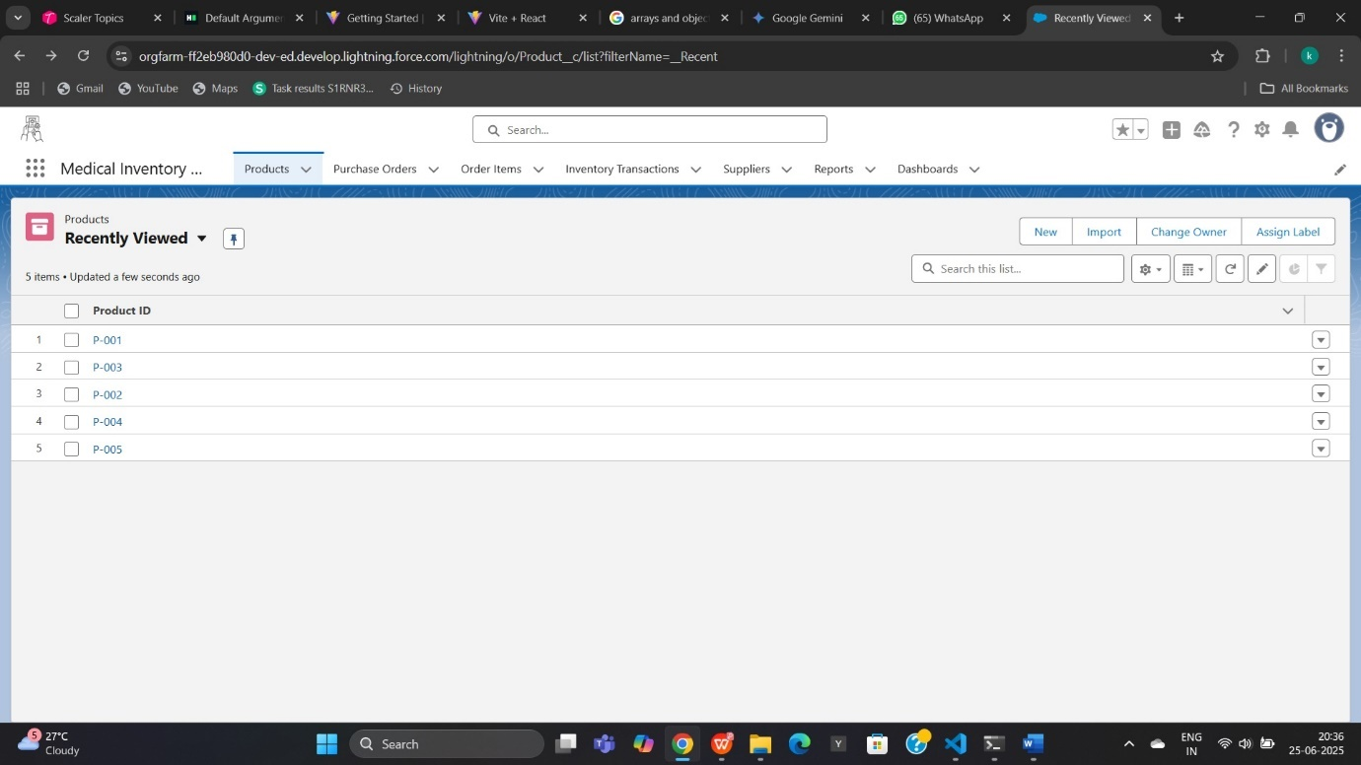

**Sample Product:**

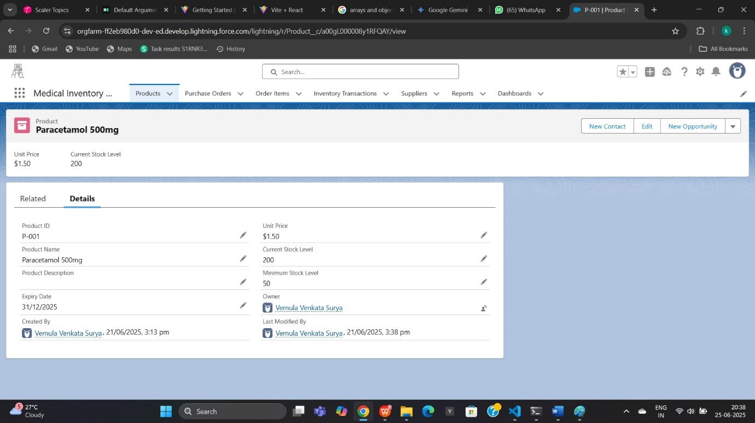

**PURCHASE ORDER TAB:**

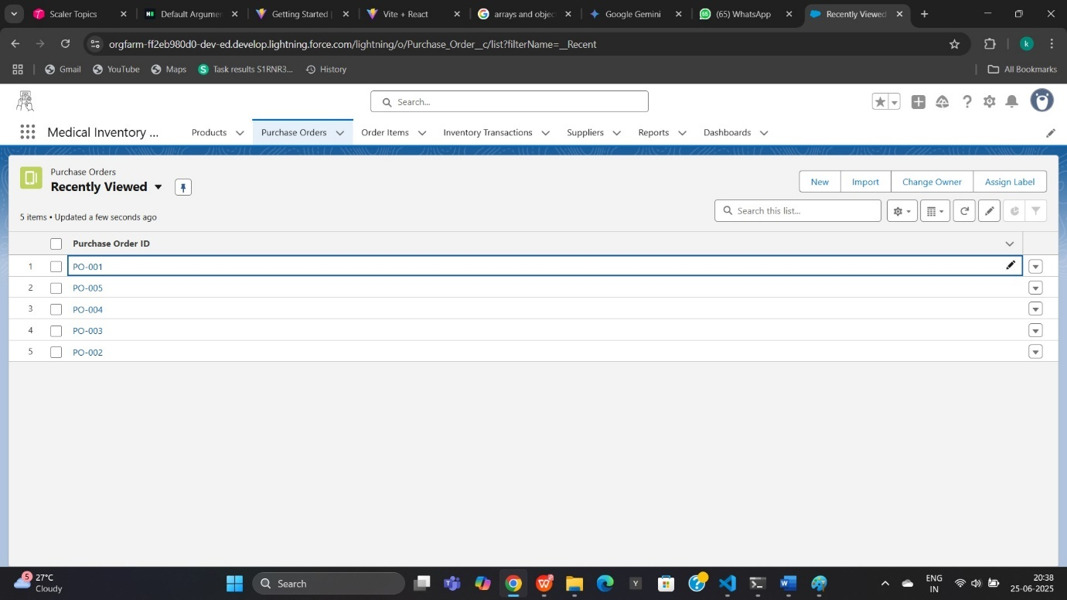

**Sample Purchase Order:**

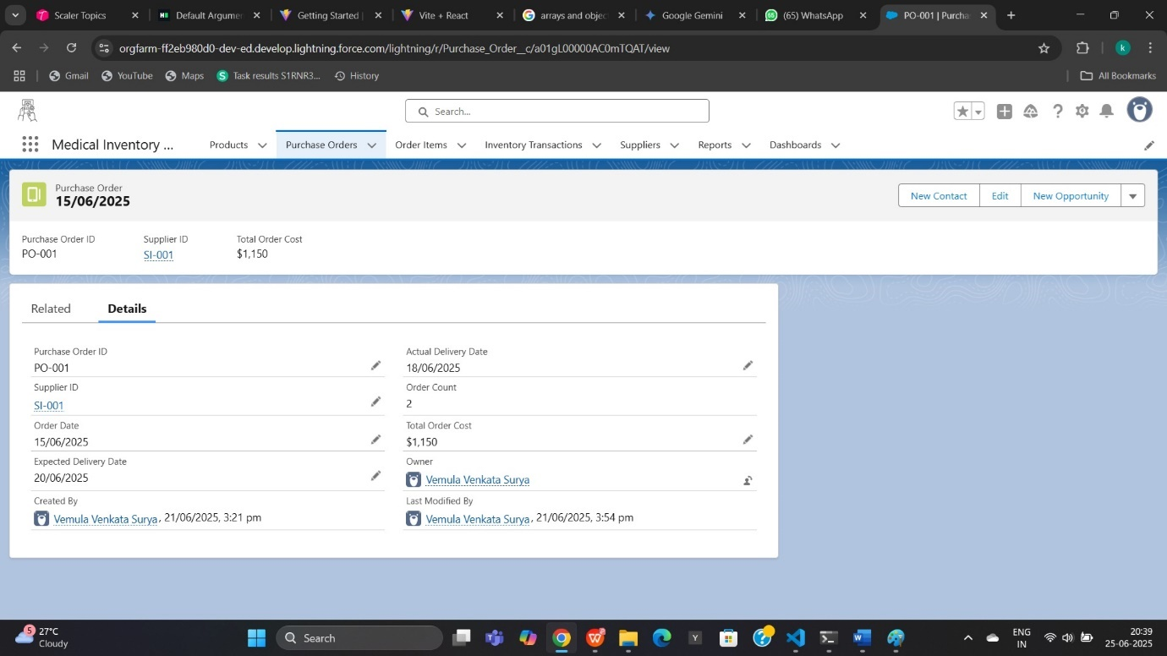

**ORDER ITEM:**

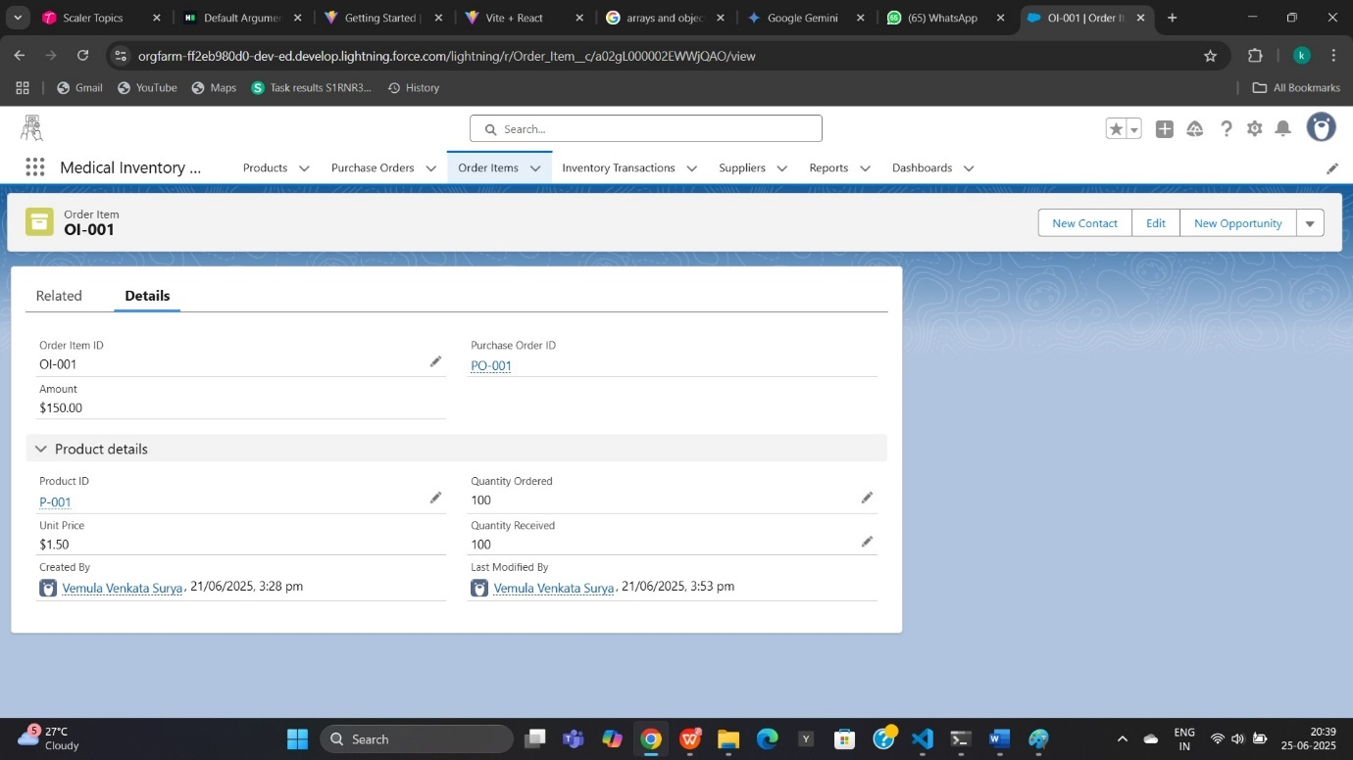

**DASHBOARD:**

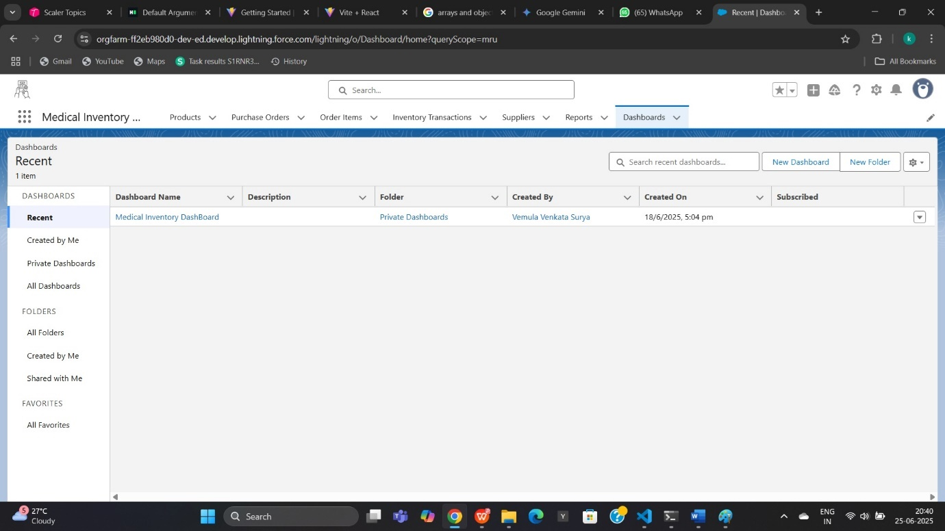

**Purchase Orders Based On Suppliers:**

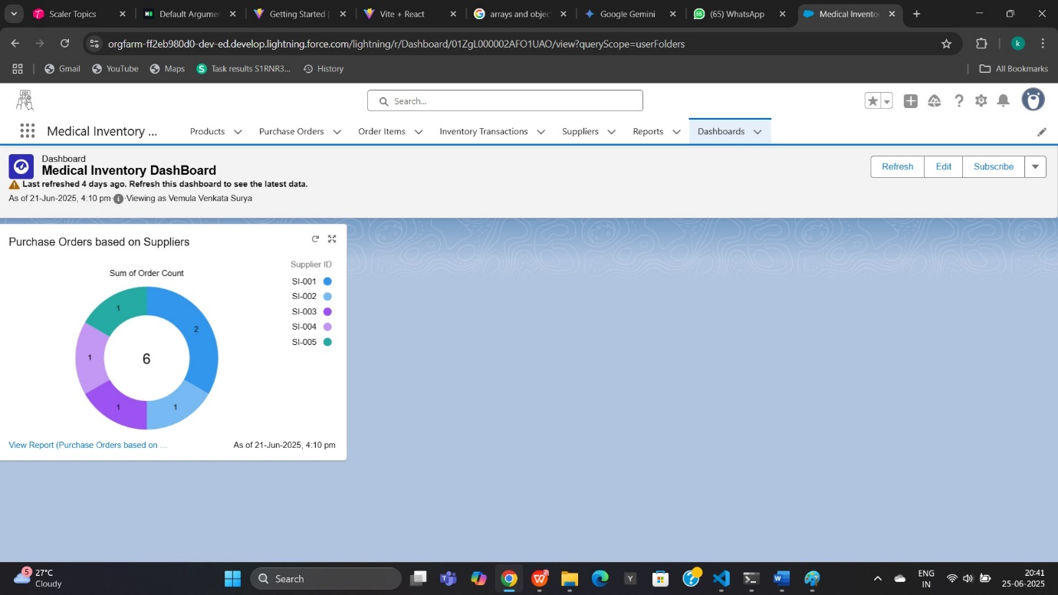

These screenshots collectively illustrate the user-friendly interface and critical data visibility offered by the Medical Inventory Management System on Salesforce, confirming its operational capabilities and direct impact on improving inventory control.

**8. ADVANTAGES & DISADVANTAGES**

Implementing a Medical Inventory Management System on the Salesforce platform brings a multitude of benefits, transforming operational efficiency and patient care. However, like any significant technological adoption, it also comes with certain considerations and potential challenges. This section provides a balanced overview of these aspects.

**8.1 Advantages**

The key advantages of deploying this Salesforce-based Medical Inventory Management System include:

* **Enhanced Real-time Visibility and Accuracy:**
  + **Single Source of Truth:** Centralizes all inventory data, eliminating fragmented spreadsheets and disparate systems, providing accurate, real-time stock levels across all locations.
  + **Reduced Manual Errors:** Digitized processes and barcode scanning minimize human errors in data entry, leading to higher inventory accuracy.
  + **Improved Decision Making:** Access to real-time, accurate data empowers management and procurement teams to make informed decisions on purchasing, stock allocation, and cost control.
* **Optimized Inventory Levels and Reduced Waste:**
  + **Prevention of Stockouts:** Automated reorder alerts ensure timely replenishment of critical supplies, safeguarding patient care and avoiding costly emergency purchases.
  + **Minimization of Overstocking:** Better demand visibility and reorder point management reduce excess inventory, freeing up capital and storage space.
  + **Effective Expiry Management:** Robust tracking of batch numbers and expiry dates, coupled with automated alerts, significantly reduces waste from expired or obsolete products, enhancing patient safety.
* **Streamlined Operations and Increased Efficiency:**
  + **Automated Workflows:** Salesforce Flows automate routine tasks like stock updates, alerts, and approvals, freeing up staff from manual, repetitive work.
  + **Faster Procurement Cycle:** Digitalized purchase order creation, approval, and receiving processes accelerate the entire procurement cycle.
  + **Improved Traceability:** Comprehensive audit trails for all stock movements enhance accountability and simplify regulatory compliance.
* **Scalability and Future-Readiness:**
  + **Cloud-Native Scalability:** Salesforce's architecture inherently supports growth in inventory volume, users, and locations without needing significant infrastructure investments.
  + **Flexible Customization:** The platform's declarative and programmatic tools allow for easy adaptation to evolving business needs and integration of new functionalities.
  + **API-First Design:** Facilitates seamless future integrations with other hospital systems (EHR, ERP) and external partners, creating a connected healthcare ecosystem.
* **Enhanced Regulatory Compliance and Patient Safety:**
  + **Robust Audit Trails:** Provides detailed records of all inventory transactions, crucial for regulatory audits and tracing specific items.
  + **Expiry Date Enforcement:** Reduces the risk of administering expired medications or using outdated supplies, directly contributing to patient safety.
  + **Data Security:** Leverages Salesforce's enterprise-grade security features, ensuring the protection of sensitive inventory data.
* **Mobile Accessibility:**
  + The Salesforce Mobile App allows staff to perform inventory tasks (e.g., receiving, dispensing, stock counts) directly at the point of care or in the warehouse using mobile devices, improving on-the-spot efficiency.

**8.2 Disadvantages**

While the advantages are substantial, it's important to consider potential challenges and disadvantages associated with the implementation:

* **Initial Setup and Configuration Effort:**
  + **Complexity:** Designing and configuring a comprehensive inventory system, especially with custom objects and flows, requires significant expertise and time in the initial phase.
  + **Data Migration:** Migrating existing, often messy, inventory data from legacy systems or spreadsheets can be a time-consuming and challenging process requiring careful planning and validation.
* **Licensing Costs:**
  + Salesforce is a premium cloud platform, and its licensing costs can be a significant investment, especially for a large number of users. Ongoing subscription fees must be factored into the operational budget.
* **Training Requirements and User Adoption:**
  + **Change Management:** Introducing a new system requires a strong change management strategy. Users accustomed to manual processes may resist adopting the new system, potentially leading to low utilization.
  + **Training Investment:** Adequate training is essential to ensure users are proficient. This requires time and resources for developing training materials and conducting sessions.
* **Dependency on Internet Connectivity:**
  + As a cloud-based system, constant and reliable internet connectivity is crucial. In areas with poor or intermittent internet access within the healthcare facility, this could pose operational challenges for real-time updates.
* **Customization Complexity and Maintenance:**
  + While customization is an advantage, over-customization with extensive Apex code or complex Lightning Web Components can increase maintenance overhead, potential for technical debt, and make future upgrades more challenging. A balance between declarative and programmatic solutions is key.
* **Integration Challenges (if complex):**
  + While Salesforce offers robust APIs, integrating with deeply entrenched legacy EHR or ERP systems can still be complex, requiring specialized integration expertise and potentially middleware solutions, adding to project costs and timelines.
* **Learning Curve for Administrators:**
  + Managing and extending a Salesforce solution requires administrators with specialized skills and continuous learning to keep up with Salesforce releases and best practices.

Despite these potential disadvantages, careful planning, robust change management, and a focus on best practices can effectively mitigate most of these challenges, making the Medical Inventory Management System on Salesforce a highly valuable asset for any healthcare organization.

**9. CONCLUSION**

The implementation of the Medical Inventory Management System on the Salesforce platform represents a significant leap forward in optimizing healthcare operations. This project has meticulously designed a solution that directly addresses the long-standing challenges of inefficiency, inaccuracy, and lack of visibility inherent in traditional medical inventory practices.

By leveraging Salesforce's powerful capabilities, we have created a system that promises to deliver **real-time, accurate, and actionable insights** into all aspects of medical inventory. From the initial procurement of supplies to their final consumption by patients, every movement is systematically tracked, ensuring data integrity and providing a comprehensive audit trail. The automated workflows and intelligent alerts for reorder points and expiry dates will drastically reduce manual errors, prevent costly stockouts, and minimize waste from expired goods.

The core strength of this solution lies in its ability to centralize data, streamline processes, and empower various stakeholders – from pharmacy managers and procurement officers to nurses and store keepers – with the tools they need to perform their roles efficiently and effectively. The user-centric design, combined with mobile accessibility, ensures high user adoption and operational flexibility across the healthcare facility.

Ultimately, this Medical Inventory Management System is more than just a technological upgrade; it is a **strategic investment in patient safety, operational efficiency, and financial prudence**. By ensuring that critical medical supplies are always available, accurately tracked, and optimally managed, the system directly contributes to improved patient outcomes and the overall quality of care. It positions the healthcare organization to meet stringent regulatory compliance requirements with greater ease and confidence.

In conclusion, the successful deployment of this Salesforce-based system will transform medical inventory management from a reactive, error-prone burden into a proactive, precise, and data-driven function, setting a new standard for operational excellence in healthcare.

**10. FUTURE SCOPE**

The current Medical Inventory Management System on Salesforce provides a robust foundation for efficient inventory operations. However, the inherent flexibility and extensibility of the Salesforce platform allow for continuous enhancement and integration with the broader healthcare ecosystem. This section outlines potential future developments and enhancements that could be considered for subsequent phases of the project.

**10.1 Phase 2 Enhancements**

1. **Integration with Electronic Health Record (EHR) Systems:**
   * **Functionality:** Establish real-time, bi-directional integration with the hospital's EHR system. This would allow for:
     + Automated dispensing of medications directly linked to patient prescriptions in the EHR.
     + Recording consumption of supplies against patient records in the inventory system, which then updates the EHR.
     + Triggering inventory requests from the EHR when a medical procedure is scheduled.
   * **Benefit:** Reduces manual entry, improves patient charge capture, enhances patient safety by linking medication administration to inventory, and provides a holistic view of patient care costs.
2. **Integration with Financial / Enterprise Resource Planning (ERP) Systems:**
   * **Functionality:** Seamless integration with the hospital's accounting or ERP software (e.g., SAP, Oracle, Tally, Microsoft Dynamics).
   * **Integration Points:**
     + Pushing validated purchase orders from Salesforce to the ERP for financial processing.
     + Automated creation of goods receipt notes in the ERP upon inventory receipt in Salesforce.
     + Feeding inventory valuation data into the financial ledger.
     + Reconciliation of supplier invoices.
   * **Benefit:** Streamlines financial operations, improves accuracy of cost accounting, and reduces duplicate data entry.
3. **Advanced Analytics and Demand Forecasting:**
   * **Functionality:** Utilize Salesforce Einstein Analytics (Tableau CRM) or integrate with external analytical tools to:
     + Perform predictive analysis on consumption patterns based on historical data, seasonality, and patient demographics.
     + Generate optimized reorder suggestions and purchase plans.
     + Identify slow-moving or obsolete inventory proactively.
   * **Benefit:** Moves from reactive to proactive inventory management, leading to significant cost savings, reduced waste, and improved stock availability.
4. **Supplier Relationship Management (SRM) Portal:**
   * **Functionality:** Develop a Community Cloud-based portal for key suppliers to:
     + View outstanding purchase orders and their status.
     + Submit advanced shipping notices (ASNs).
     + Upload product catalogs and pricing updates.
     + Collaborate on discrepancies or returns.
   * **Benefit:** Enhances supplier collaboration, reduces communication overhead, and improves inbound logistics efficiency.
5. **RFID / Advanced Barcoding Solutions:**
   * **Functionality:** Explore integration with more advanced automated identification technologies like RFID for high-value assets or high-volume consumables.
   * **Benefit:** Enables even faster and more accurate inventory counts (e.g., cycle counting), automated stock tracking in specific zones, and enhanced security against theft.
6. **Mobile Offline Capabilities:**
   * **Functionality:** Enhance the Salesforce Mobile App to support offline data entry for inventory movements in areas with limited or no internet connectivity (e.g., remote clinics, specific hospital zones with poor Wi-Fi). Data would sync once connectivity is restored.
   * **Benefit:** Ensures continuity of operations in all environments, improving system usability and data capture.
7. **IoT Integration for Environmental Monitoring:**
   * **Functionality:** Integrate with IoT sensors to monitor critical storage conditions (temperature, humidity) for sensitive medical items (e.g., vaccines, specialized drugs) directly within Salesforce.
   * **Benefit:** Ensures regulatory compliance for storage conditions, prevents spoilage, and triggers alerts for out-of-range conditions.
8. **Patient Charge Capture Automation:**
   * **Functionality:** Automatically generate patient charges in the billing system based on items dispensed and consumed, directly from the inventory system.
   * **Benefit:** Improves revenue capture accuracy, reduces manual billing errors, and streamlines the patient billing process.
9. **Integration with Prescription Management Systems:**
   * **Functionality:** For pharmacies, integrate with e-prescription systems to directly pull prescription details into the inventory system for dispensing and tracking.
   * **Benefit:** Increases dispensing accuracy, provides real-time inventory checks against prescriptions, and improves overall pharmacy workflow.

**10.2 Ongoing Maintenance & Support**

Beyond new features, continuous attention to maintenance and support will be critical for the long-term success of the system:

* **Regular System Health Checks:** Periodically review Salesforce Optimizer and Health Check reports to identify and address potential performance, security, or configuration issues.
* **Salesforce Release Management:** Plan for and adapt to Salesforce's three annual releases, leveraging new features and ensuring compatibility.
* **User Feedback & Enhancements:** Establish a formal channel for users to submit feedback and enhancement requests, fostering continuous improvement.
* **Data Archiving Strategy:** Periodically review and execute data archiving plans for historical Stock_Movement__c records to maintain system performance.
* **Training Refreshers:** Conduct periodic training refreshers for existing users and comprehensive onboarding for new staff.

By planning for these future enhancements and committing to ongoing support, the Medical Inventory Management System on Salesforce can evolve into an even more powerful and indispensable tool for healthcare organizations, driving efficiency, compliance, and ultimately, better patient care.

**11. APPENDIX**

The Appendix provides supplementary information that supports the main report, including technical details, links to external resources, and a glossary of terms.

**11.1 Source Code (if any)**

11.2 Dataset Link

11.3 <https://github.com/Zeuss163/Medical-Inventory-Management>